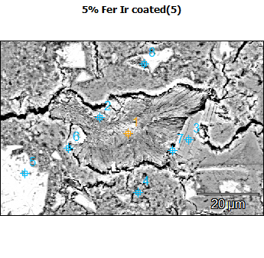
Image Name: 5% Fer Ir coated(5)
Image Resolution: 512 by 340
Image Pixel Size: 0.17 µm
Acc. Voltage: 10.0 kV
Magnification: 2500
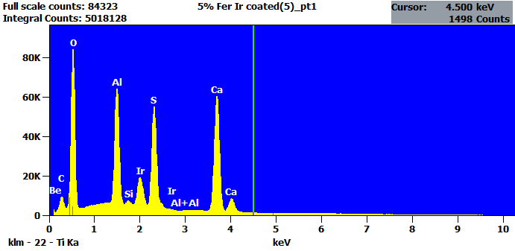
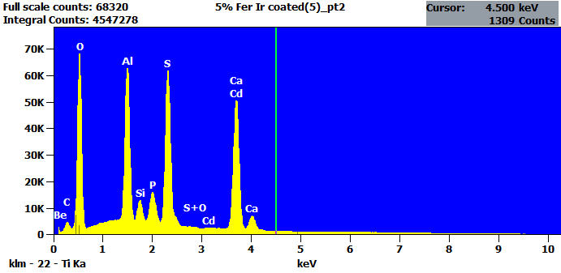

Image Name: 5% Fer Ir coated(5)
Image Resolution: 512 by 340
Image Pixel Size: 0.17 µm
Acc. Voltage: 10.0 kV
Magnification: 2500
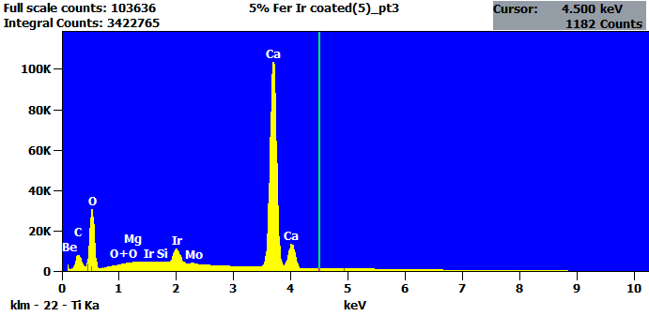
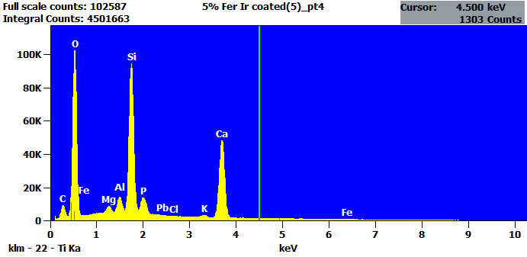

Image Name: 5% Fer Ir coated(5)
Image Resolution: 512 by 340
Image Pixel Size: 0.17 µm
Acc. Voltage: 10.0 kV
Magnification: 2500
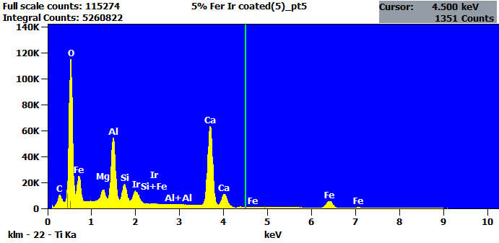
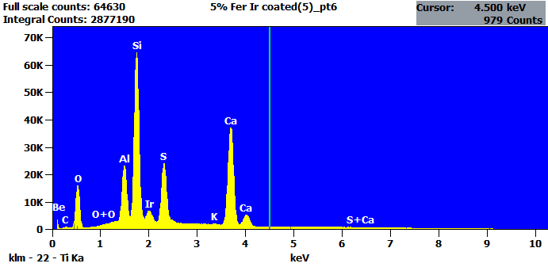

Image Name: 5% Fer Ir coated(5)
Image Resolution: 512 by 340
Image Pixel Size: 0.17 µm
Acc. Voltage: 10.0 kV
Magnification: 2500
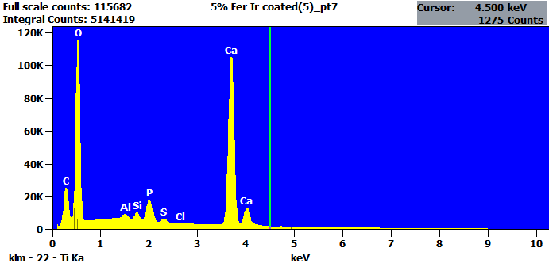
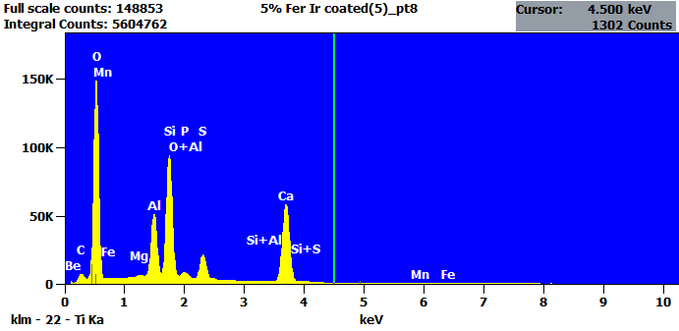

Net Counts
 | Be | C | O | Mg | Al | Si | P | S | Cl | K | Ca | Mn | Fe | Mo | Cd | Ir | Pb
5% Fer Ir coated(5)_pt1 | 0 | 90272 | 740374 |  | 649524 | 27754 |  | 745689 |  |  | 858418 |  |  |  |  | 284576
5% Fer Ir coated(5)_pt2 | 0 | 41338 | 606475 |  | 643185 | 94412 | 186337 | 846332 |  |  | 725764 |  |  |  | 10822
5% Fer Ir coated(5)_pt3 | 0 | 66454 | 258011 | 337 |  | 6340 |  |  |  |  | 1515064 |  |  | 9575 |  | 130436
5% Fer Ir coated(5)_pt4 |  | 73862 | 928640 | 40454 | 98972 | 1043669 | 159690 |  | 1440 | 25854 | 623870 |  | 6751 |  |  |  | 3480
5% Fer Ir coated(5)_pt5 |  | 81807 | 970613 | 86689 | 523062 | 155629 |  |  |  |  | 940572 |  | 267699 |  |  | 176974
5% Fer Ir coated(5)_pt6 | 630 | 4722 | 141030 |  | 216577 | 712506 |  | 309475 |  | 1903 | 531208 |  |  |  |  | 79472
5% Fer Ir coated(5)_pt7 |  | 245064 | 1000064 |  | 32612 | 47193 | 207583 | 42303 | 3347 |  | 1512741
5% Fer Ir coated(5)_pt8 | 0 | 66218 | 1269444 | 8634 | 499567 | 1052141 | 76831 | 258023 |  |  | 774601 | 1639 | 13775

Intensity
 | Be | C | O | Mg | Al | Si | P | S | Cl | K | Ca | Mn | Fe | Mo | Cd | Ir | Pb
5% Fer Ir coated(5)_pt1 | --- | --- | --- |  | --- | --- |  | --- |  |  | --- |  |  |  |  | ---
5% Fer Ir coated(5)_pt2 | --- | --- | --- |  | --- | --- | --- | --- |  |  | --- |  |  |  | ---
5% Fer Ir coated(5)_pt3 | --- | --- | --- | --- |  | --- |  |  |  |  | --- |  |  | --- |  | ---
5% Fer Ir coated(5)_pt4 |  | --- | --- | --- | --- | --- | --- |  | --- | --- | --- |  | --- |  |  |  | ---
5% Fer Ir coated(5)_pt5 |  | --- | --- | --- | --- | --- |  |  |  |  | --- |  | --- |  |  | ---
5% Fer Ir coated(5)_pt6 | --- | --- | --- |  | --- | --- |  | --- |  | --- | --- |  |  |  |  | ---
5% Fer Ir coated(5)_pt7 |  | --- | --- |  | --- | --- | --- | --- | --- |  | ---
5% Fer Ir coated(5)_pt8 | --- | --- | --- | --- | --- | --- | --- | --- |  |  | --- | --- | ---

Weight %
 | Be | C | O | Mg | Al | Si | P | S | Cl | K | Ca | Mn | Fe | Mo | Cd | Ir | Pb
5% Fer Ir coated(5)_pt1 | 0.00 | 2.15 | 32.44 |  | 8.97 | 0.43 |  | 13.03 |  |  | 33.90 |  |  |  |  | 9.08
5% Fer Ir coated(5)_pt2 | 0.00 | 1.42 | 31.62 |  | 10.29 | 1.70 | 3.44 | 17.08 |  |  | 33.73 |  |  |  | 0.72
5% Fer Ir coated(5)_pt3 | 0.00 | 0.94 | 20.44 | 0.01 |  | 0.12 |  |  |  |  | 73.05 |  |  | 0.35 |  | 5.10
5% Fer Ir coated(5)_pt4 |  | 2.02 | 42.24 | 0.69 | 1.64 | 18.70 | 3.18 |  | 0.04 | 0.97 | 29.51 |  | 0.86 |  |  |  | 0.15
5% Fer Ir coated(5)_pt5 |  | 1.22 | 30.51 | 1.18 | 6.72 | 2.14 |  |  |  |  | 31.27 |  | 21.93 |  |  | 5.03
5% Fer Ir coated(5)_pt6 | 0.27 | 0.30 | 14.35 |  | 5.76 | 21.03 |  | 11.02 |  | 0.12 | 41.83 |  |  |  |  | 5.33
5% Fer Ir coated(5)_pt7 |  | 2.75 | 41.79 |  | 0.40 | 0.62 | 2.80 | 0.62 | 0.06 |  | 50.96
5% Fer Ir coated(5)_pt8 | 0.00 | 1.47 | 42.62 | 0.11 | 6.29 | 14.64 | 1.16 | 4.17 |  |  | 27.92 | 0.30 | 1.32

Atom %
 | Be | C | O | Mg | Al | Si | P | S | Cl | K | Ca | Mn | Fe | Mo | Cd | Ir | Pb
5% Fer Ir coated(5)_pt1 | 0.00 | 4.65 | 52.61 |  | 8.63 | 0.39 |  | 10.54 |  |  | 21.95 |  |  |  |  | 1.23
5% Fer Ir coated(5)_pt2 | 0.00 | 2.93 | 49.06 |  | 9.47 | 1.50 | 2.76 | 13.23 |  |  | 20.89 |  |  |  | 0.16
5% Fer Ir coated(5)_pt3 | 0.00 | 2.43 | 39.76 | 0.01 |  | 0.13 |  |  |  |  | 56.73 |  |  | 0.11 |  | 0.83
5% Fer Ir coated(5)_pt4 |  | 3.78 | 59.41 | 0.64 | 1.37 | 14.98 | 2.31 |  | 0.03 | 0.56 | 16.57 |  | 0.35 |  |  |  | 0.02
5% Fer Ir coated(5)_pt5 |  | 2.84 | 53.25 | 1.36 | 6.95 | 2.13 |  |  |  |  | 21.78 |  | 10.96 |  |  | 0.73
5% Fer Ir coated(5)_pt6 | 0.89 | 0.74 | 26.92 |  | 6.40 | 22.48 |  | 10.32 |  | 0.09 | 31.33 |  |  |  |  | 0.83
5% Fer Ir coated(5)_pt7 |  | 5.38 | 61.30 |  | 0.35 | 0.52 | 2.12 | 0.45 | 0.04 |  | 29.84
5% Fer Ir coated(5)_pt8 | 0.00 | 2.76 | 60.02 | 0.10 | 5.25 | 11.74 | 0.85 | 2.93 |  |  | 15.69 | 0.12 | 0.53

