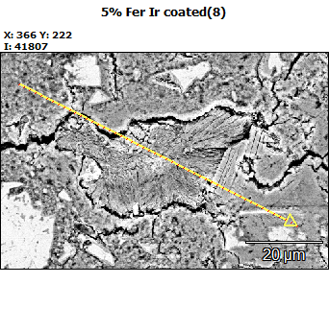
Accelerating Voltage: 10.0 kV
Magnification: 2500

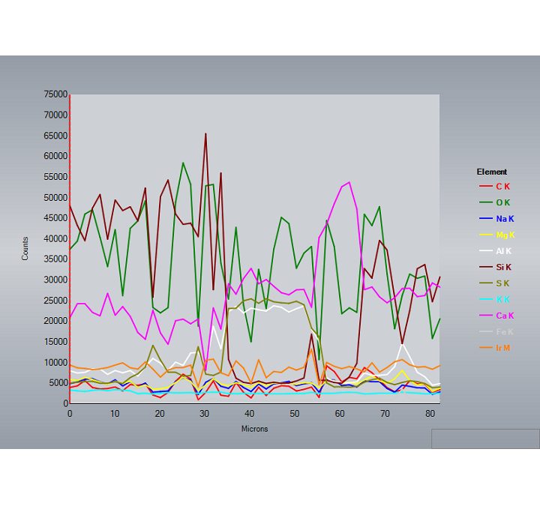
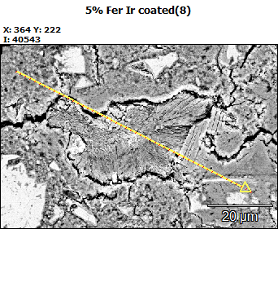
Accelerating Voltage: 10.0 kV
Magnification: 2500

