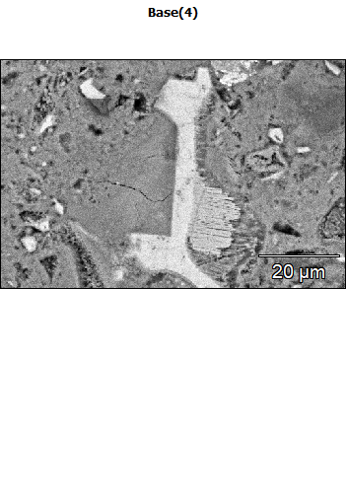
Data Type: Counts
Image Resolution: 512 by 340
Image Pixel Size: 0.17 µm
Map Resolution: 512 by 340
Map Pixel Size: 0.17 µm
Acc. Voltage: 15.1 kV
Magnification: 2500
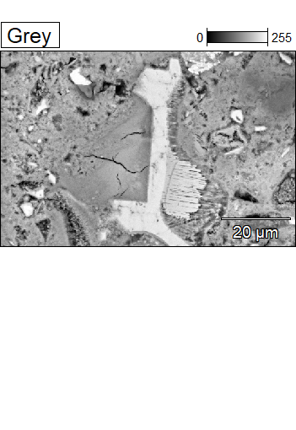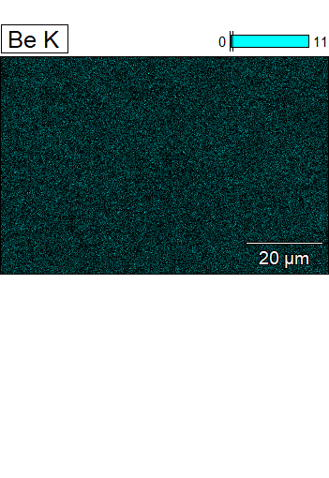

Data Type: Counts
Image Resolution: 512 by 340
Image Pixel Size: 0.17 µm
Map Resolution: 512 by 340
Map Pixel Size: 0.17 µm
Acc. Voltage: 15.1 kV
Magnification: 2500
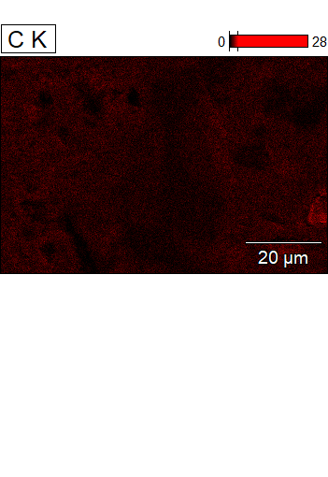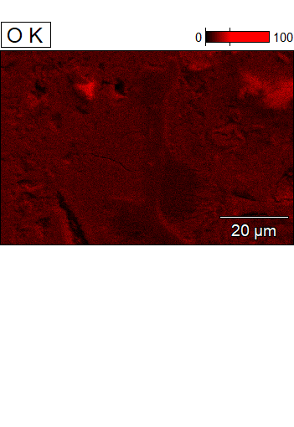

Data Type: Counts
Image Resolution: 512 by 340
Image Pixel Size: 0.17 µm
Map Resolution: 512 by 340
Map Pixel Size: 0.17 µm
Acc. Voltage: 15.1 kV
Magnification: 2500
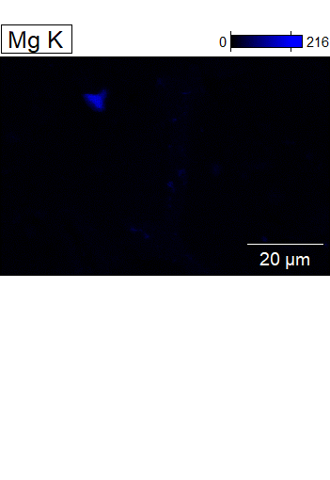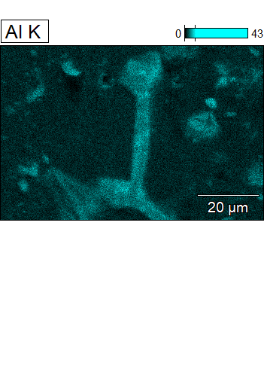

Data Type: Counts
Image Resolution: 512 by 340
Image Pixel Size: 0.17 µm
Map Resolution: 512 by 340
Map Pixel Size: 0.17 µm
Acc. Voltage: 15.1 kV
Magnification: 2500
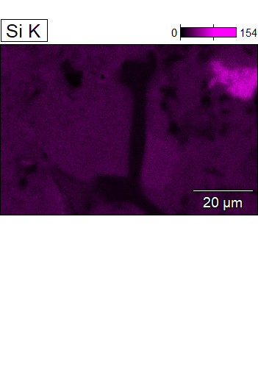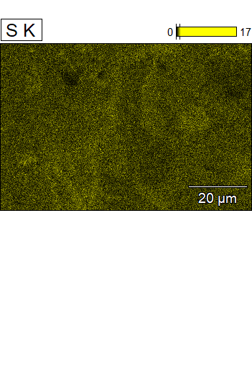

Data Type: Counts
Image Resolution: 512 by 340
Image Pixel Size: 0.17 µm
Map Resolution: 512 by 340
Map Pixel Size: 0.17 µm
Acc. Voltage: 15.1 kV
Magnification: 2500
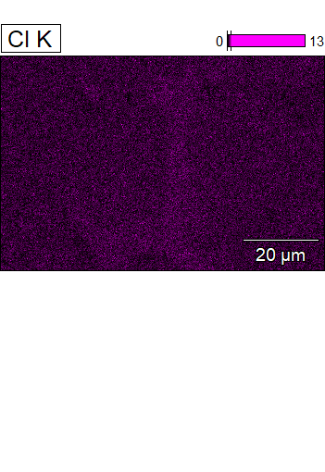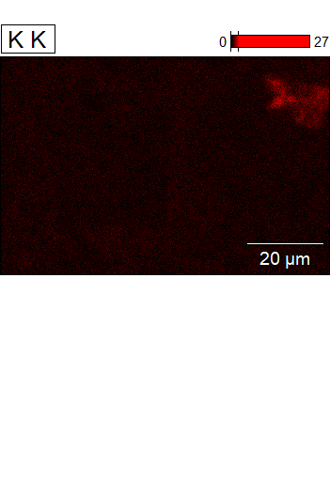

Data Type: Counts
Image Resolution: 512 by 340
Image Pixel Size: 0.17 µm
Map Resolution: 512 by 340
Map Pixel Size: 0.17 µm
Acc. Voltage: 15.1 kV
Magnification: 2500
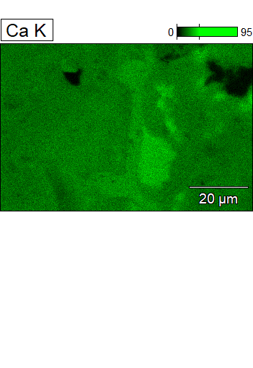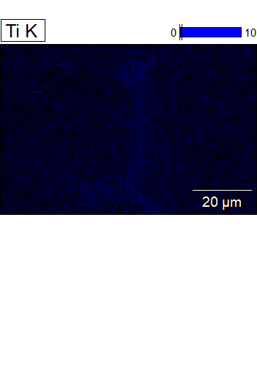

Data Type: Counts
Image Resolution: 512 by 340
Image Pixel Size: 0.17 µm
Map Resolution: 512 by 340
Map Pixel Size: 0.17 µm
Acc. Voltage: 15.1 kV
Magnification: 2500
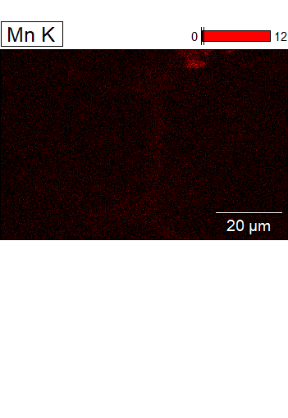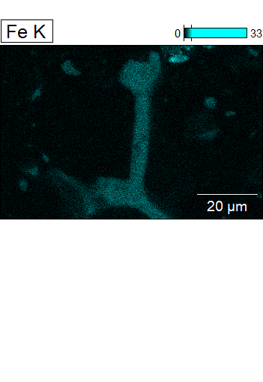

Data Type: Counts
Image Resolution: 512 by 340
Image Pixel Size: 0.17 µm
Map Resolution: 512 by 340
Map Pixel Size: 0.17 µm
Acc. Voltage: 15.1 kV
Magnification: 2500
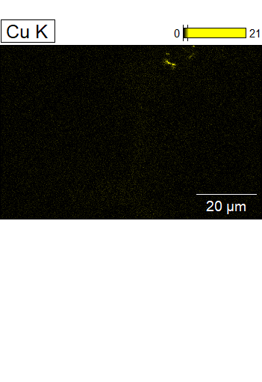
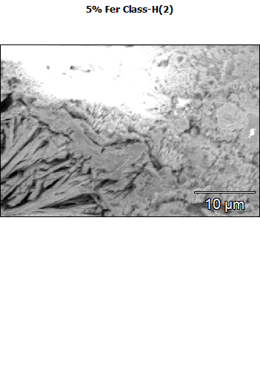
Data Type: Counts
Image Resolution: 512 by 340
Image Pixel Size: 0.08 µm
Map Resolution: 512 by 340
Map Pixel Size: 0.08 µm
Acc. Voltage: 10.1 kV
Magnification: 5000
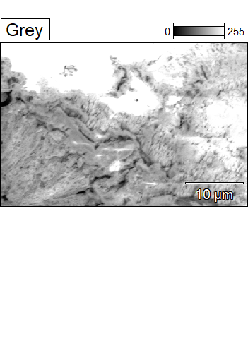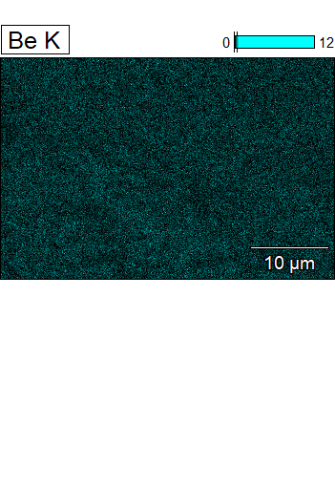

Data Type: Counts
Image Resolution: 512 by 340
Image Pixel Size: 0.08 µm
Map Resolution: 512 by 340
Map Pixel Size: 0.08 µm
Acc. Voltage: 10.1 kV
Magnification: 5000
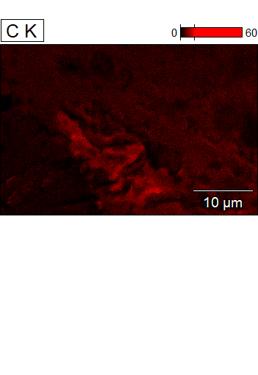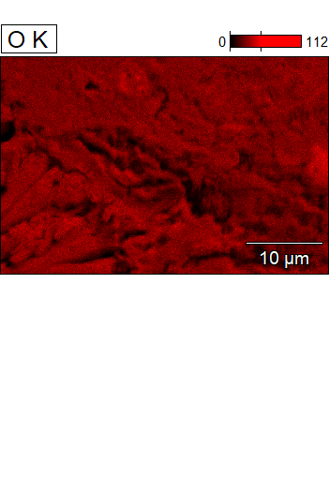

Data Type: Counts
Image Resolution: 512 by 340
Image Pixel Size: 0.08 µm
Map Resolution: 512 by 340
Map Pixel Size: 0.08 µm
Acc. Voltage: 10.1 kV
Magnification: 5000
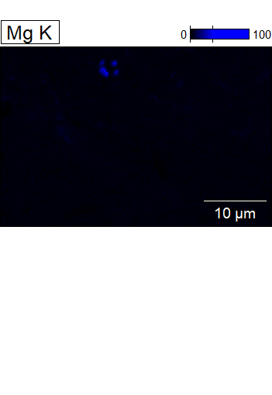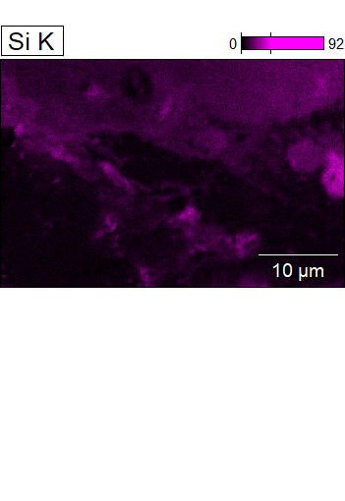

Data Type: Counts
Image Resolution: 512 by 340
Image Pixel Size: 0.08 µm
Map Resolution: 512 by 340
Map Pixel Size: 0.08 µm
Acc. Voltage: 10.1 kV
Magnification: 5000
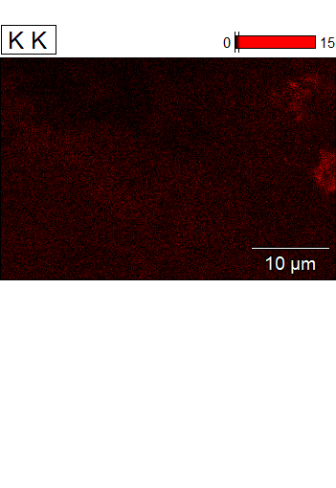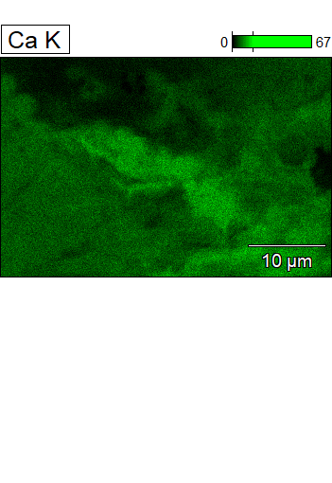

Data Type: Counts
Image Resolution: 512 by 340
Image Pixel Size: 0.08 µm
Map Resolution: 512 by 340
Map Pixel Size: 0.08 µm
Acc. Voltage: 10.1 kV
Magnification: 5000
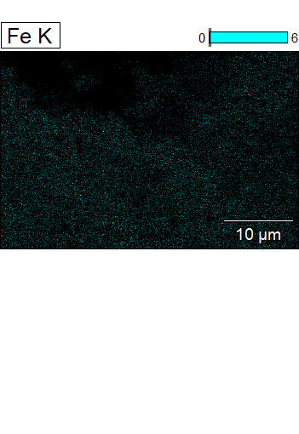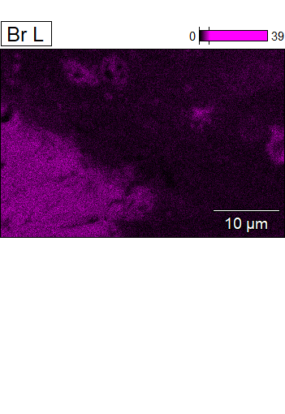

Data Type: Counts
Image Resolution: 512 by 340
Image Pixel Size: 0.08 µm
Map Resolution: 512 by 340
Map Pixel Size: 0.08 µm
Acc. Voltage: 10.1 kV
Magnification: 5000
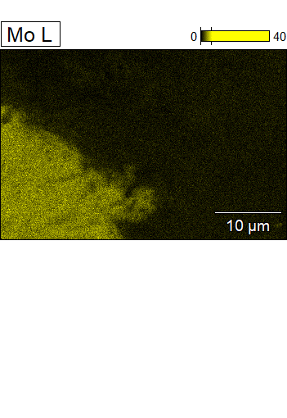
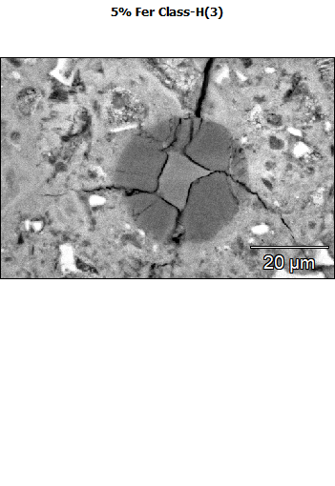
Data Type: Counts
Image Resolution: 512 by 340
Image Pixel Size: 0.17 µm
Map Resolution: 512 by 340
Map Pixel Size: 0.17 µm
Acc. Voltage: 20.1 kV
Magnification: 2500
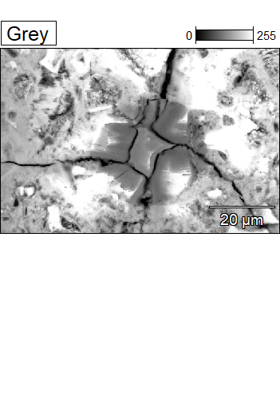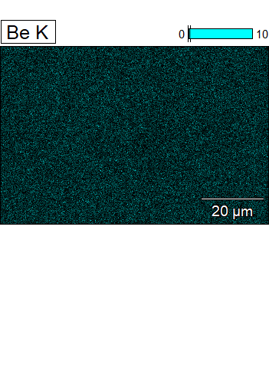

Data Type: Counts
Image Resolution: 512 by 340
Image Pixel Size: 0.17 µm
Map Resolution: 512 by 340
Map Pixel Size: 0.17 µm
Acc. Voltage: 20.1 kV
Magnification: 2500
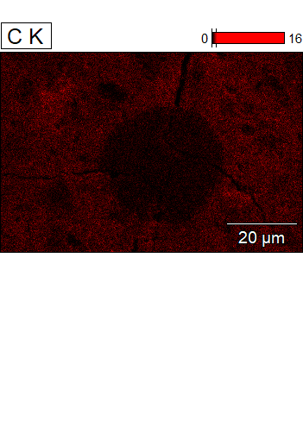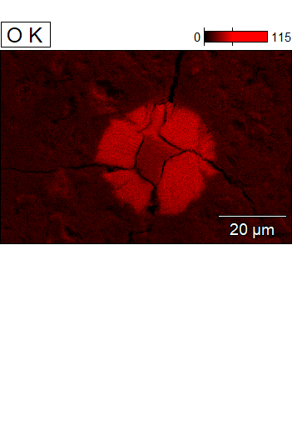

Data Type: Counts
Image Resolution: 512 by 340
Image Pixel Size: 0.17 µm
Map Resolution: 512 by 340
Map Pixel Size: 0.17 µm
Acc. Voltage: 20.1 kV
Magnification: 2500
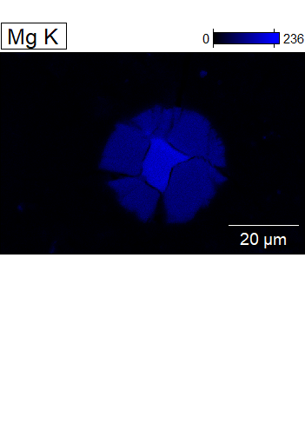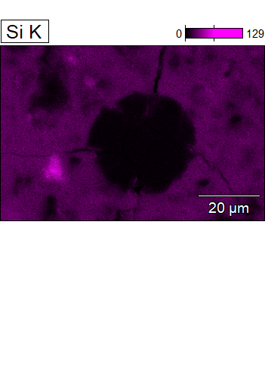

Data Type: Counts
Image Resolution: 512 by 340
Image Pixel Size: 0.17 µm
Map Resolution: 512 by 340
Map Pixel Size: 0.17 µm
Acc. Voltage: 20.1 kV
Magnification: 2500
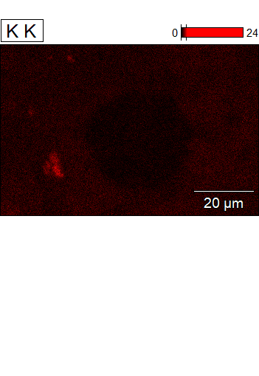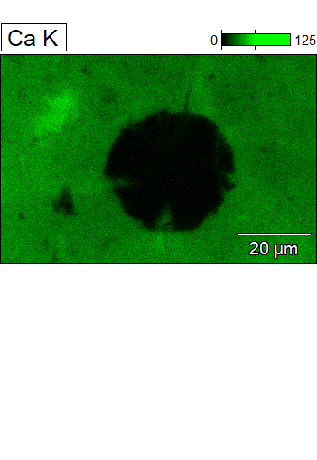

Data Type: Counts
Image Resolution: 512 by 340
Image Pixel Size: 0.17 µm
Map Resolution: 512 by 340
Map Pixel Size: 0.17 µm
Acc. Voltage: 20.1 kV
Magnification: 2500
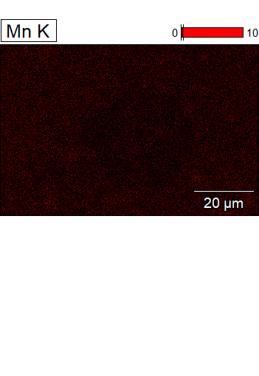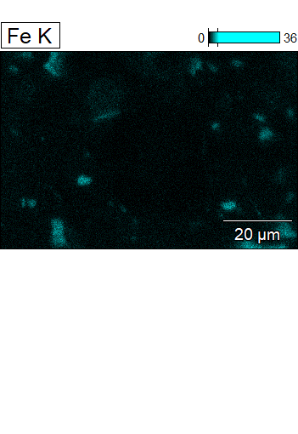

Data Type: Counts
Image Resolution: 512 by 340
Image Pixel Size: 0.17 µm
Map Resolution: 512 by 340
Map Pixel Size: 0.17 µm
Acc. Voltage: 20.1 kV
Magnification: 2500
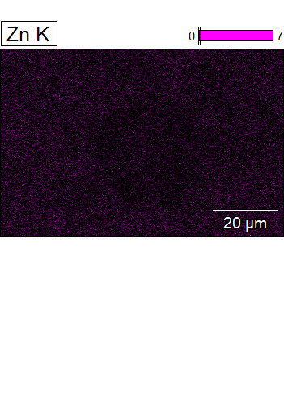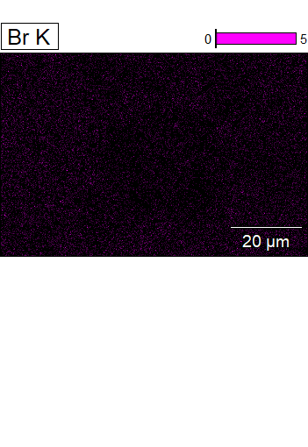

Data Type: Counts
Image Resolution: 512 by 340
Image Pixel Size: 0.17 µm
Map Resolution: 512 by 340
Map Pixel Size: 0.17 µm
Acc. Voltage: 20.1 kV
Magnification: 2500
