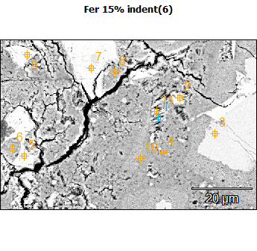
Image Name: Fer 15% indent(6)
Image Resolution: 512 by 340
Image Pixel Size: 0.17 µm
Acc. Voltage: 10.0 kV
Magnification: 2500
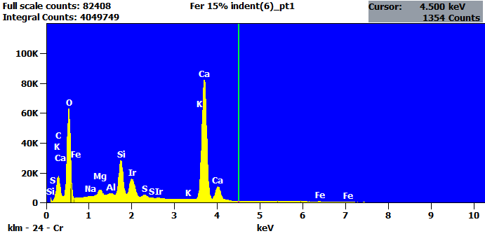
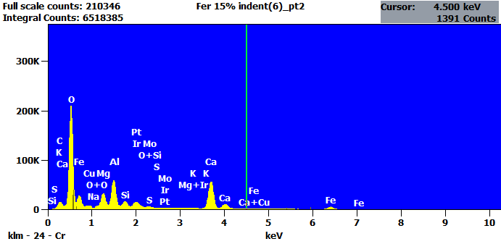

Image Name: Fer 15% indent(6)
Image Resolution: 512 by 340
Image Pixel Size: 0.17 µm
Acc. Voltage: 10.0 kV
Magnification: 2500
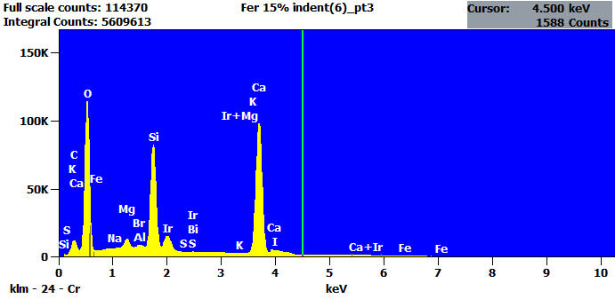
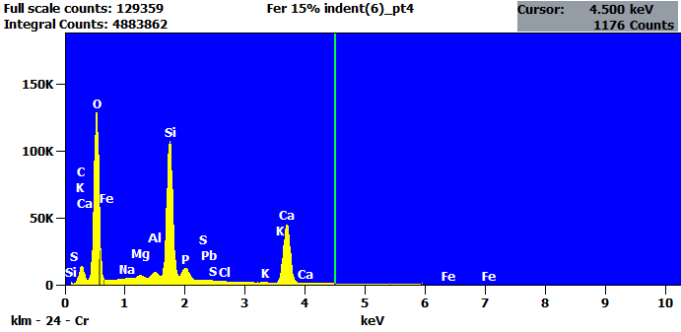

Image Name: Fer 15% indent(6)
Image Resolution: 512 by 340
Image Pixel Size: 0.17 µm
Acc. Voltage: 10.0 kV
Magnification: 2500
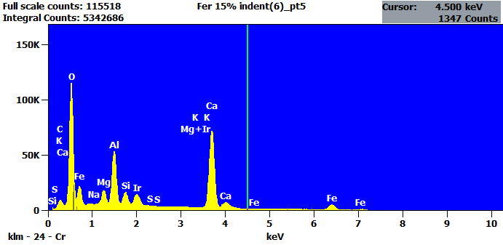
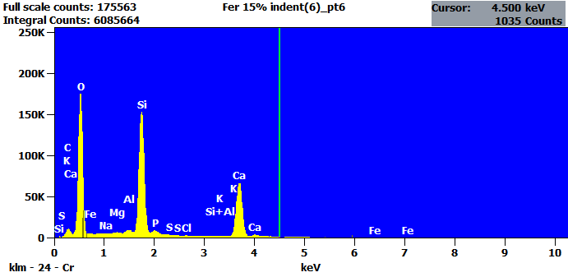

Image Name: Fer 15% indent(6)
Image Resolution: 512 by 340
Image Pixel Size: 0.17 µm
Acc. Voltage: 10.0 kV
Magnification: 2500
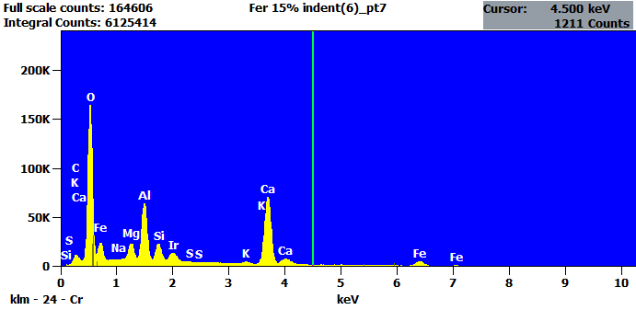
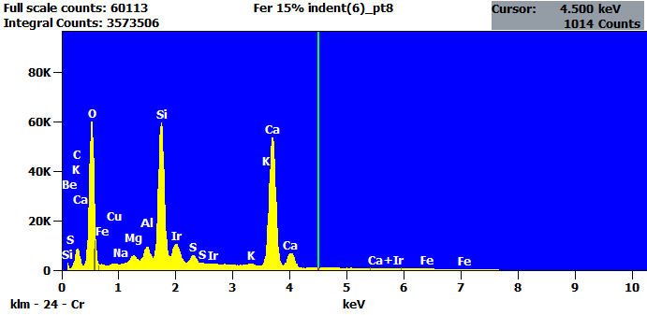

Image Name: Fer 15% indent(6)
Image Resolution: 512 by 340
Image Pixel Size: 0.17 µm
Acc. Voltage: 10.0 kV
Magnification: 2500
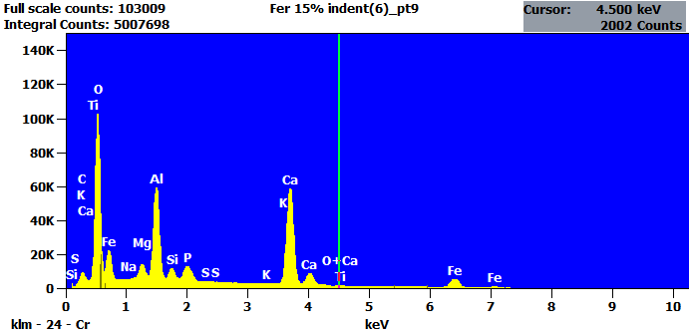
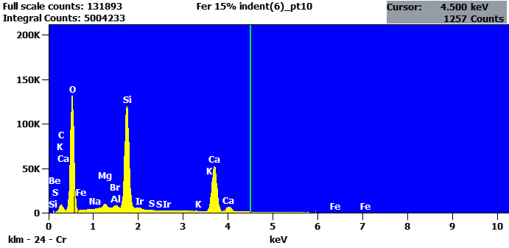

Image Name: Fer 15% indent(6)
Image Resolution: 512 by 340
Image Pixel Size: 0.17 µm
Acc. Voltage: 10.0 kV
Magnification: 2500
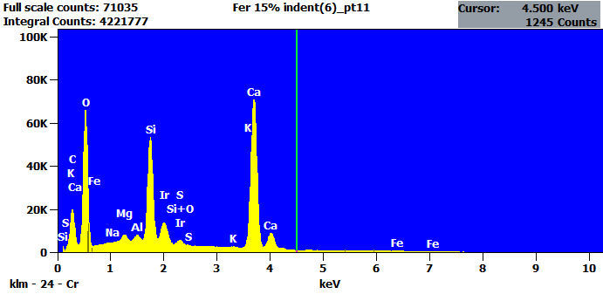

Net Counts
 | Be | C | O | Na | Mg | Al | Si | P | S | Cl | K | Ca | Ti | Fe | Cu | Br | Mo | I | Ir | Pt | Pb | Bi
Fer 15% indent(6)_pt1 |  | 165707 | 538223 | 0 | 42227 | 12902 | 281615 |  | 28304 |  | 4723 | 1181198 |  | 3378 |  |  |  |  | 227761
Fer 15% indent(6)_pt2 |  | 146368 | 1744109 | 0 | 311778 | 564295 | 110113 |  | 0 |  | 2478 | 835790 |  | 248272 | 0 |  | 24736 |  | 187037 | 0
Fer 15% indent(6)_pt3 |  | 116555 | 1007831 | 2639 | 67324 | 18527 | 901345 |  | 0 |  | 3411 | 1482006 |  | 1718 |  | 0 |  | 94102 | 208643 |  |  | 12279
Fer 15% indent(6)_pt4 |  | 131473 | 1173168 | 5222 | 25168 | 47084 | 1205192 | 138227 | 0 | 3741 | 12225 | 583641 |  | 13209 |  |  |  |  |  |  | 10351
Fer 15% indent(6)_pt5 |  | 88363 | 984393 | 0 | 128076 | 516122 | 129153 |  | 323 |  | 5173 | 999925 |  | 226359 |  |  |  |  | 184330
Fer 15% indent(6)_pt6 |  | 100660 | 1536215 | 4888 | 11990 | 38852 | 1757833 | 76057 | 981 | 2196 | 8774 | 920736 |  | 11305
Fer 15% indent(6)_pt7 |  | 110678 | 1377200 | 1503 | 167102 | 619268 | 196975 |  | 0 |  | 24965 | 978138 |  | 249660 |  |  |  |  | 168711
Fer 15% indent(6)_pt8 | 0 | 79998 | 540210 | 0 | 35206 | 56891 | 652129 |  | 47567 |  | 9121 | 768843 |  | 6664 | 0 |  |  |  | 139037
Fer 15% indent(6)_pt9 |  | 90780 | 864503 | 0 | 86380 | 595121 | 70046 | 138876 | 240 |  | 0 | 849100 | 5615 | 240864
Fer 15% indent(6)_pt10 | 3204 | 82578 | 1151232 | 2231 | 43817 | 21240 | 1316255 |  | 0 |  | 5429 | 746472 |  | 0 |  | 0 |  |  | 25579
Fer 15% indent(6)_pt11 |  | 188758 | 574081 | 0 | 30273 | 22728 | 565977 |  | 34120 |  | 5238 | 1018348 |  | 3830 |  |  |  |  | 181707

Intensity
 | Be | C | O | Na | Mg | Al | Si | P | S | Cl | K | Ca | Ti | Fe | Cu | Br | Mo | I | Ir | Pt | Pb | Bi
Fer 15% indent(6)_pt1 |  | --- | --- | --- | --- | --- | --- |  | --- |  | --- | --- |  | --- |  |  |  |  | ---
Fer 15% indent(6)_pt2 |  | --- | --- | --- | --- | --- | --- |  | --- |  | --- | --- |  | --- | --- |  | --- |  | --- | ---
Fer 15% indent(6)_pt3 |  | --- | --- | --- | --- | --- | --- |  | --- |  | --- | --- |  | --- |  | --- |  | --- | --- |  |  | ---
Fer 15% indent(6)_pt4 |  | --- | --- | --- | --- | --- | --- | --- | --- | --- | --- | --- |  | --- |  |  |  |  |  |  | ---
Fer 15% indent(6)_pt5 |  | --- | --- | --- | --- | --- | --- |  | --- |  | --- | --- |  | --- |  |  |  |  | ---
Fer 15% indent(6)_pt6 |  | --- | --- | --- | --- | --- | --- | --- | --- | --- | --- | --- |  | ---
Fer 15% indent(6)_pt7 |  | --- | --- | --- | --- | --- | --- |  | --- |  | --- | --- |  | --- |  |  |  |  | ---
Fer 15% indent(6)_pt8 | --- | --- | --- | --- | --- | --- | --- |  | --- |  | --- | --- |  | --- | --- |  |  |  | ---
Fer 15% indent(6)_pt9 |  | --- | --- | --- | --- | --- | --- | --- | --- |  | --- | --- | --- | ---
Fer 15% indent(6)_pt10 | --- | --- | --- | --- | --- | --- | --- |  | --- |  | --- | --- |  | --- |  | --- |  |  | ---
Fer 15% indent(6)_pt11 |  | --- | --- | --- | --- | --- | --- |  | --- |  | --- | --- |  | --- |  |  |  |  | ---

Weight %
 | Be | C | O | Na | Mg | Al | Si | P | S | Cl | K | Ca | Ti | Fe | Cu | Br | Mo | I | Ir | Pt | Pb | Bi
Fer 15% indent(6)_pt1 |  | 2.66 | 30.81 | 0.00 | 0.70 | 0.21 | 4.75 |  | 0.55 |  | 0.16 | 51.58 |  | 0.43 |  |  |  |  | 8.15
Fer 15% indent(6)_pt2 |  | 1.84 | 40.51 | 0.00 | 3.56 | 6.17 | 1.29 |  | 0.00 |  | 0.06 | 23.67 |  | 17.84 | 0.00 |  | 0.55 |  | 4.51 | 0.00
Fer 15% indent(6)_pt3 |  | 1.39 | 33.18 | 0.03 | 0.75 | 0.20 | 10.13 |  | 0.00 |  | 0.07 | 42.66 |  | 0.15 |  | 0.00 |  | 6.02 | 5.07 |  |  | 0.35
Fer 15% indent(6)_pt4 |  | 3.28 | 45.45 | 0.09 | 0.40 | 0.72 | 19.74 | 2.53 | 0.00 | 0.10 | 0.42 | 25.32 |  | 1.54 |  |  |  |  |  |  | 0.42
Fer 15% indent(6)_pt5 |  | 1.28 | 31.59 | 0.00 | 1.72 | 6.54 | 1.76 |  | 0.00 |  | 0.13 | 32.99 |  | 18.82 |  |  |  |  | 5.17
Fer 15% indent(6)_pt6 |  | 1.78 | 45.23 | 0.06 | 0.14 | 0.43 | 20.98 | 1.02 | 0.01 | 0.04 | 0.22 | 29.11 |  | 0.98
Fer 15% indent(6)_pt7 |  | 1.44 | 35.92 | 0.02 | 1.96 | 6.88 | 2.36 |  | 0.00 |  | 0.58 | 28.38 |  | 18.29 |  |  |  |  | 4.18
Fer 15% indent(6)_pt8 | 0.00 | 2.07 | 33.24 | 0.00 | 0.69 | 1.08 | 13.27 |  | 1.14 |  | 0.38 | 40.93 |  | 0.97 | 0.00 |  |  |  | 6.23
Fer 15% indent(6)_pt9 |  | 1.61 | 30.77 | 0.00 | 1.33 | 8.61 | 1.10 | 2.20 | 0.00 |  | 0.00 | 31.83 | 0.39 | 22.17
Fer 15% indent(6)_pt10 | 0.86 | 1.83 | 44.60 | 0.04 | 0.65 | 0.30 | 20.25 |  | 0.00 |  | 0.17 | 30.40 |  | 0.00 |  | 0.00 |  |  | 0.90
Fer 15% indent(6)_pt11 |  | 3.60 | 31.86 | 0.00 | 0.51 | 0.37 | 9.74 |  | 0.69 |  | 0.18 | 45.78 |  | 0.49 |  |  |  |  | 6.79

Atom %
 | Be | C | O | Na | Mg | Al | Si | P | S | Cl | K | Ca | Ti | Fe | Cu | Br | Mo | I | Ir | Pt | Pb | Bi
Fer 15% indent(6)_pt1 |  | 5.97 | 51.89 | 0.00 | 0.78 | 0.21 | 4.56 |  | 0.46 |  | 0.11 | 34.68 |  | 0.21 |  |  |  |  | 1.14
Fer 15% indent(6)_pt2 |  | 3.80 | 62.55 | 0.00 | 3.62 | 5.65 | 1.13 |  | 0.00 |  | 0.04 | 14.59 |  | 7.89 | 0.00 |  | 0.14 |  | 0.58 | 0.00
Fer 15% indent(6)_pt3 |  | 3.11 | 55.54 | 0.04 | 0.83 | 0.20 | 9.65 |  | 0.00 |  | 0.05 | 28.50 |  | 0.07 |  | 0.00 |  | 1.27 | 0.71 |  |  | 0.04
Fer 15% indent(6)_pt4 |  | 5.91 | 61.49 | 0.09 | 0.35 | 0.57 | 15.21 | 1.77 | 0.00 | 0.06 | 0.23 | 13.67 |  | 0.60 |  |  |  |  |  |  | 0.04
Fer 15% indent(6)_pt5 |  | 2.91 | 54.14 | 0.00 | 1.94 | 6.65 | 1.72 |  | 0.00 |  | 0.09 | 22.57 |  | 9.24 |  |  |  |  | 0.74
Fer 15% indent(6)_pt6 |  | 3.28 | 62.39 | 0.06 | 0.13 | 0.35 | 16.49 | 0.73 | 0.01 | 0.03 | 0.12 | 16.03 |  | 0.39
Fer 15% indent(6)_pt7 |  | 3.10 | 58.20 | 0.02 | 2.09 | 6.61 | 2.18 |  | 0.00 |  | 0.38 | 18.36 |  | 8.49 |  |  |  |  | 0.56
Fer 15% indent(6)_pt8 | 0.00 | 4.40 | 53.18 | 0.00 | 0.73 | 1.02 | 12.09 |  | 0.91 |  | 0.25 | 26.14 |  | 0.45 | 0.00 |  |  |  | 0.83
Fer 15% indent(6)_pt9 |  | 3.58 | 51.42 | 0.00 | 1.46 | 8.53 | 1.04 | 1.90 | 0.00 |  | 0.00 | 21.23 | 0.22 | 10.61
Fer 15% indent(6)_pt10 | 2.09 | 3.34 | 61.08 | 0.04 | 0.59 | 0.25 | 15.80 |  | 0.00 |  | 0.10 | 16.62 |  | 0.00 |  | 0.00 |  |  | 0.10
Fer 15% indent(6)_pt11 |  | 7.71 | 51.27 | 0.00 | 0.54 | 0.35 | 8.93 |  | 0.55 |  | 0.12 | 29.40 |  | 0.22 |  |  |  |  | 0.91

