
Zeolite Ferrierite: an additive for enhanced wellbore cement plugs
S.V.K. Vissa¹, M. Radonjic¹*
¹Geomimicry Materials Laboratory, School of Chemical engineering, EN 420, Oklahoma State University, Stillwater OK, 74074
*corresponding author: mileva.radonjic@okstate.edu
Abstract:

In the oil and gas industry, drilling and completions of wellbores have undergone major technological improvements, that ultimately enabled safer exploration and production of fossil fuels. However, the plugging and abandonment (P&A) of wellbores, is only recently calling for the same level of technological advancements, primarily due to an increased number of P&A campaigns in the North Sea. Wellbore plugging in offshore environments is challenging as the consequence of potential hydrocarbon leakage can cause cumulative damage to the fragile ecosystems for a long time before detection. Gas leakage is especially hard to detect and evaluate for appropriate wellbore intervention and mitigation. Preventing wellbore leakage requires a robust sealing material capable of reducing the permeability through wellbore infrastructure to zero for thousands of years. The main goal is the restoration of the original geological seal. Portland cement-based cement plugs are not compatible with the geochemistry of subsurface and with current designs would not provide long term durability required. Addition of zeolites to cement is an appealing solution. Zeolites potentially act as scaffoldings for cement hydration reactions primarily due to similar structures with Calcium Silicate Hydrate (CSH), they have compatibility. This paper is focused on evaluation of a natural zeolite ferrierite, primarily microstructural characterization and its chemical stability in contact with fluids that resemble potential subsurface formation fluids. We did not observe major alterations in ferrierite when exposed to low pH aqueous solution, high salinity brine, synthetic oil and water after 7days exposure at 95˚C. The cement cores made containing ferrierite show improved mechanical properties for 5% bwoc ferrierite, and microstructure that suggests potential fracture bridging.
Key words: zeolites, wellbore plugging and abandonment, self-healing, hydraulic barrier material.
Introduction:
Inadequate plugging of offshore wellbores releases upward migrating hydrocarbons over the course of decades, resulting in cumulative damage to surrounding fragile ecosystems, like the deep-water ecosystems in the Gulf of Mexico (GoM). The cement formulations which would be developed for the offshore GoM wells can serve as a model for other offshore oil wells. This research seeks to enhance safety by preventing wellbore leakage, protecting environment from oil/gas contaminations, and catalyzing scientific advances benefitting the GoM region and eventually other offshore regions such as the North Sea, offshore west Africa, offshore Brazil..
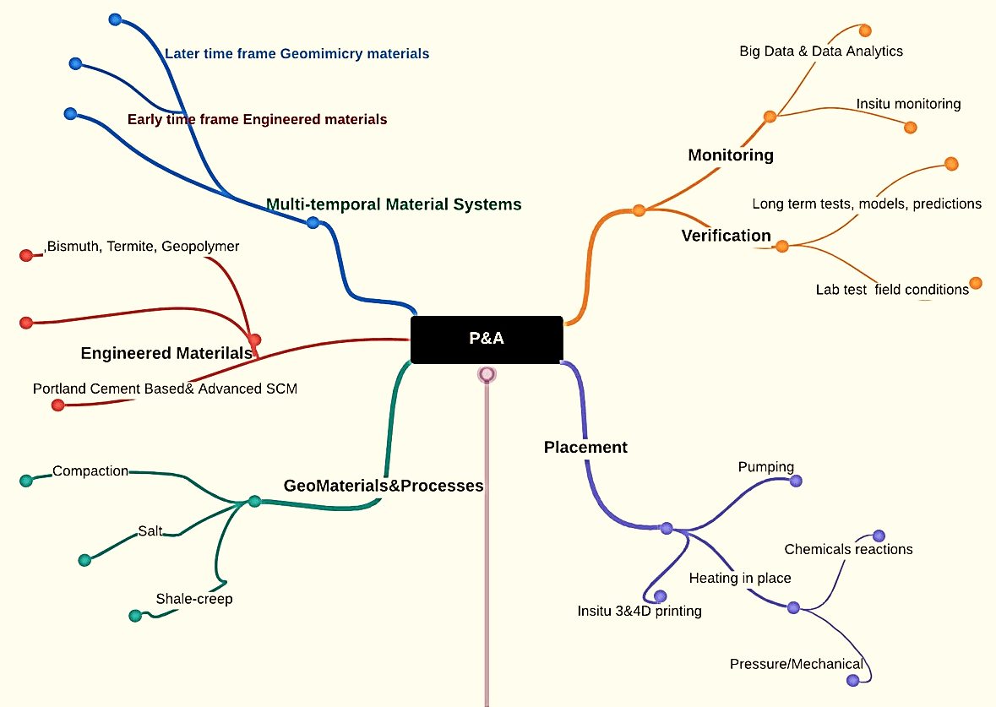
Figure 1— An outlook into designing barrier materials for wellbore plugging and abandonment applications.

In the beginning of this work, a literature survey was done to understand the drawbacks that are seen in Portland cement, like low resistance to chemical attacks, development of microfractures and other related problems. The literature survey also helped in getting an insight into the various types of supplementary cementitious materials, as well as cement additives that were added to enhance the properties of the hydration products of Portland cement-based slurries, typically used in wellbore construction. The main focus is on the compatibility with the geological formations as well as subsurface fluids, and operational conditions encountered during production, stimulations and wellbore interventions.

Mechanical Strength

Long-term Resilience

Petro-physical properties

Plugging materials

Chemical stability
Formation compatibility

HPHT

Figure 2— Key Properties that determine effectiveness of plugging barrier materials.

The aim of this research is to design a wellbore plugging barrier material capable of withstanding changing subsurface conditions and restoring geological seals back to pre-drilling conditions. The key points to be considered for a good barrier material are:
- Low porosity and ideally zero permeability.
- Increased tensile / shear strength and resilience to fracturing.
- Chemicals compatibility with the geological formations.
- Resistance to chemical attacks due to injected fluids, such as CO2 sequestration.
- Durability under high pressure and temperature conditions (HPHT).
In order to achieve these properties, it is a matter of utmost importance to choose the right material for a given wellbore conditions as well as adequate placement and whenever possible test cement slurries in the lab as close to reservoir conditions as possible. Brady et al., [1] mentions the importance of choosing the right cement slurry among the various technologies that are used in wellbores like those in Gulf of Mexico. Noting the importance of the right plugging material, this research is directed towards finding a solution for the optimal formulation to be used to create a long-lasting barrier. We start with the cement that is to be used. Portland cement is the most common base hydraulic barrier material which has been used for wellbore construction and plugging applications [2-4]. Many challenges have been seen especially in plugging of deep-water wells Rassenfoss et al [5], also hints on the usage of additive materials in cement to enhance the properties as a scope for future research. Class-H cements has been one of the preferred materials for offshore plugging purposes like in the Gulf of Mexico (GoM). In this research, the aim is to decide a right additive that can be added to Class-H cements which we have chosen for our testing as a barrier material. Next, we explore the various supplementary cementitious materials. Out of all the studied materials like pozzolans, blast furnace slag, silica fume, and fly ash, which had been commonly used with cement for various applications, zeolites are of interest since they have engineerable properties. Zeolites are available abundantly in nature and had seen prior usage in Geothermal well cements (REF). In addition, the fibrous and porous morphology of the zeolites act like a substrate for the crystal growth of CSH during hydration and, had shown an increase in the strength and chemical stability of the cement. Before moving on to class-H studies, it is important to get an idea of how zeolites interact with Portland cement in general, and how zeolites perform in comparison to other well-known cement additives.

Blast furnace slag had been used to give thermal stability and was found to be effective at temperature ranges of ∼200-300˚C [6]. Silica fume reduces the porosity and permeability, and had also shown some advantages in the rheological properties of cement [7]. Pozzolans, like lime and metakaolin, had been used for ages and had shown better hydration strength properties in cement as they actively took part in the hydration reaction and had also contributed to late strength development due to the same [8]. Fly ash has been used since ancient times, and has shown to increase the strength of cement by taking part in the hydration reaction, and also showing filler effect similar to silica fume occupying the pore spaces and reducing the porosity and permeability of resultant cement [9-11]

Poon C.S. et al [12], Chen J.J. et al [13]Ahmadi B et al [14] and Feng N.Q et al [15], had shown an increase in the strength of the cement composition on addition of zeolites. V.Lilkov et al [16], had done an extensive study on how addition of various zeolites affects the hydration of cement by studying the hydration products of cement. Poon C.S. et al had also shown that the porosity of cement samples was affected by the addition of zeolites. Th. Perraki et al [17], has studied the early hydration characteristics of cement on addition of zeolites. The effect of zeolite addition had also been compared with silica fume and metakaolin additions by Valipour M. et al [18]. Markiv T. et al [19] had tested the freeze thaw resistance, as well as the drying shrinkage properties of zeolite added cement. Pacewska et al [22] had studied the effect of waste zeolites from Fluidized Bed Catalytic cracking on hydration properties of cement. Najimi M. et al [23] had studied the effect of adding zeolites on resistance towards sulfate attack, workability, as well as freeze thaw resistance. Nagrockiene, D. et al [24] had shown the effect of zeolite additions on strength, freeze thaw resistance, and lowered water absorption. Zeolites are shown to improve the strength properties as well as improve the performance of cements at high temperatures and pressures. They were also shown to improve the chemical stability of cement [19, 23-25]. The hydration properties have also been improved owing to the improved surface area provided as a substrate for hydration to take place, which is due to the periodic porosity seen in zeolites, which helps in transfer of ions during the hydration reaction creating a very good hydration matrix [12, 13, 17, 25]. Shahrabadi et al., had shown the improvement of strength and better performance of cement in sea environments upon addition of zeolites [26] which suggests the suitability for our application. The performance of cemented sands had been found to be improved on addition of zeolites which indicates that we could achieve compatibility with formation and hence a better seal [27]. An interesting property of cement which had been explored in earlier studies was the self-healing property of concrete [28]. Autogenous self-healing properties of zeolite additions in cement were studied by Su et al., [29]. In this paper, it was noted that higher percentage additions of zeolite showed a decrease in the strength after healing, which could be attributed to the blocking effect. The addition of a particular zeolite in cement had also been found to show this property according to the work of Pyatina Et al., [20]. The formulation used in these studies was the one that was adopted to obtain the low-density commercial zeolite cement used in geothermal applications. We would be using this particular zeolite cement in our studies to observe the interaction of zeolite with cement. The zeolite in consideration in this paper is ferrierite. The properties of this zeolite were studied extensively by Rice et.al., [21] giving a very clear picture of the morphological structure which formed the basis of our initial study of this mineral. Work had also been done on optimizing the composite formulation with zeolites for better performance [30, 31], and based on all this literature, we have a good basis for our work.

With the available information from literature, we chose zeolites as our materials of choice. The first step is to study the properties of these zeolites to have an idea of how they would react with cement under sub surface conditions. In most of the literature studied, the morphological characters of various types of plain zeolites like clinoptilolite were studied and it was noted that they had close resemblance to the CSH particles which are observed in cement hydration. This similarity results in a synergistic effect since zeolite gets homogeneously distributed in cement without separating out as different phases which could add to the overall strength of the cement. Once the zeolites are studied to get an idea of chemical, physical and morphological properties, they can be used for addition to cement in various compositions to check the physical, petrophysical, and morphological properties of cement. The morphological studies would be done using tools like SEM (scanning electron microscope) and TEM (Transmissions Electron Microscopy). Chemical and elemental analysis would be done using the EDS (Energy dispersive X-ray spectroscopy). The phase studies and the mineral identification studies would be done using XRD (X-Ray Diffraction). The cores would be examined using CT (Computed tomography) for initial internal morphology evaluation. UCS (Unconfined compressive strength) tests would be performed on cement cores to do the strength analysis.

Materials and methods:

In this study, the chemical properties of a zeolite of interest Ferrierite was studied. Zeolites are aluminosilicate minerals which have a distinct porous crystalline structure. The zeolite rock used for the studies was obtained from Lovelock, Nevada, provided by the Trabits group. The zeolite cement which was used later in our studies, was obtained from the Trabits group as well and was produced at the Maryneal plant of Buzzi Unicem company. Each zeolite has their own characteristic morphological features. In the first part of the study, the plain zeolite rock was carefully cut into small pieces with at least two parallel faces, and then polished to a uniformity of up to 3µm by using high precision polishing with an Allied Multiprep™ polisher. These polished samples were dried, and carbon coated to be observed under the Scanning electron microscope. Ferrierite was then powdered and passed through a 425µm sieve to achieve a uniform size distribution with particles no larger than 425µm. Some plain ferrierite powder was studied under the SEM to get an idea of the basic morphological features. Elemental composition was observed using EDS. TEM was also performed at high magnifications to observe the finer morphological properties of the zeolite.

This powdered form of ferrierite was then exposed to different chemical conditions like those observed at the sub-surface. The focus of this research is to check whether the ferrierite retains its zeolitic morphology of aluminosilicate networks after exposure to these harsh conditions. It is required that the zeolite maintains the chemical and elemental composition without showing any signs of phase change or hydraulic activity in order to be considered as a good supplementary cementitious material. The following solutions had been prepared to simulate sub-surface chemical conditions. Also, Oil was added to see if there would be any change on interaction with organic material like oil based drilling fluids or even the hydrocarbons which would be produced in the reservoir.
2.5 grams of Ferrierite was immersed in each of the following - 250 mL of pH 13 Calcium Hydroxide (Ca(OH)₂) solution, 1N Hydrochloric acid (HCl) solution, 35ppt Sodium Chloride (NaCl) solution, de-ionized water, and 25mL of mineral oil. Ca(OH)₂, HCl and NaCl were acquired from fisher scientific. The Change of atomic percent of the various elements in Ferrierite were studied after keeping them in the above solutions for a week at 95˚C. The samples were regularly checked, and the solution level was maintained through out the test period. After one week, the powders were washed, cleaned repeatedly with DI water to remove excess of the chemicals, and collected on Millipore paper. The sample which was suspended in oil was washed repeatedly with isopropyl alcohol, to remove the oil from the sample and it was collected in Millipore paper like the other samples. All samples are then slowly transferred off to petri dishes, labelled and left for drying. Once the samples were dried thoroughly, they were placed on carbon taped microscopy holders, and carbon coated before performing electron microscopy.
Condition | solution | Quantity
High pH | Ca(OH)₂ solution (pH 13) | 0.5gms in 500mL DI water
Acidic (Low pH) | HCl solution (1N) | 500mL
Brine | NaCl Solution (35ppt) | 17.5gms in 500mL DI water
Water | DI water | 500mL
Oil | Mineral oil | 50mL

Table 1— Compositions of different solutions to simulate sub-surface conditions

The data was obtained by performing EDS and SEM analysis of the samples. EDS would give us an understanding of the elemental composition of the ferrierite. The reason for this kind of an analysis is to observe if there is any change in the elemental composition after interaction with the sub-surface chemical conditions. SEM is used to take high magnification images of the ferrierite to observe the morphological properties, and to determine if there is any change after interaction with the sub-surface chemical conditions. This was done using an FEI Quanta 600 Scanning electron microscope equipped with a Bruker EDS system. Also, a JEOL JEM-2100 Scanning Transmission Electron Microscope was used for TEM studies of the powdered Ferrierite. The samples were prepared for SEM and TEM by drying them for 24 hours before performing the analysis. Solid rock samples and cement cores were polished to smoothness of up to a uniformity of ∼0.6µm. These samples were then carbon coated before examining them under the SEM and performing the EDS analysis.

XRD of the samples, was done using Bruker D8 advance X-ray diffractometer to confirm the phase present in our material and compare it with the standard ferrierite XRD data from the International Centre for Diffraction Data. For XRD analysis, the samples including the rock and the hydrated cement cores were made into fine powders with a uniformity of up to ∼425µm and then made into pellets in the sample holder used for the XRD analysis. The XRD data was processed using Profex software (Version 4.1.0) which does the peak matching and refinement of the data using mineral and crystal data from its own BGMN database. JCPDS data was also referred to get the exact peak values of ferrierite mineral for our initial phase studies of the pure mineral and the study of the pure mineral after exposure to various chemical conditions for sensitivity analysis.

To get an understanding of how this cement composition is going to work, we used an existing zeolite cement formulation. This is a commercially available class-L composite well cement in which ferrierite is interground with cement clinker which has been used extensively in geothermal well construction. Intergrinding produces a bimodal particle size distribution between the harder clinker and the softer zeolite resulting in increased strength properties. This cement is claimed to be showing self-healing properties [20]. One of the purposes of this research is to see similar characteristics when zeolite is added to Class-H cement which is currently one of the preferred cements used for wellbore plugging applications. The study would include getting an understanding of how the zeolite would interact at different sub surface chemical conditions and with impurities observed in drilling and completions.

The initial study of zeolite cement included designing and making of 16 PPG slurries. This cement is usually suited for 10-13.4 PPG low density slurries and has up to 30% Ferrierite replacement in it. However, a new 16 PPG slurry design was developed with the help of industrial experts. Initially, the 16PPG designs of the zeolite were developed in our lab based on API standards for Class-H cement slurries. We observed the resultant cores under CT scanner. We used an YXLON FF20CT scanner for the 3d imaging and analysis. Microfractures were found in the initial slurry designs and industrial experts were consulted for developing the new slurries. NexTier oilfield solutions helped develop the 16 PPG slurry formulation of the zeolite cement which consisted of a heavyweight agent (NWT-310) a friction reducer (KCFR-11) and a retarder (NRT-213). The slurries were made and cores were prepared by putting them in molds, demolding after 24 hours of hydration, and curing them for 28 days in an environmental chamber at 90˚C and 95% relative humidity, simulating the borewell conditions at the sub-surface. Some cement cores were cut and polished to up to ∼0.6µm uniformity for initial SEM studies.

Once the properties of this zeolite (ferrierite) are thoroughly studied, it would be mixed in Class-H cement in varying proportions and tested for physical and petrophysical properties. The goal as mentioned earlier is to optimize this cement design for wellbore plugging application. Slurries with 5%, 15% and 30% additions of Ferrierite in Class-H cements are made and are currently undergoing testing. Preliminary strength analysis on ~28-30 days of curing shows that 5% additions of Ferrierite have a noticeable effect on the unconfined compressive strength (UCS) of the resultant cement cores.

For the UCS tests, the samples were cut with 2:1 aspect ratio per ASTM standards, and ground parallel to within 1 thousandth/inch. Pre-test dimensions of the cement cores and their mass was measured for piston control settings. Samples were loaded at constant strain rate, 1e^-5/sec. The load was applied in the following manner:

1) load piston actuated in stress control until 50 psi reached.
2) The piston was then switched to strain (position) control.
3) Sample is loaded at constant rate until failure, and then unloaded.

The peak stress condition was calculated from load cell force measurement and sample diameter, reported in the results section. A servo-hydraulic computer-controlled load frame from James Cox and Sons was used to perform the UCS tests.

Results and discussion:

Ferrierite is basically an Aluminosilicate mineral with varying cation concentrations of Na⁺, Mg⁺, and K⁺ giving its distinct porous crystalline structure which is characteristic of zeolites. The initial part of this study is to observe the basic morphological features of the mineral characterizing it based on the features and attributes mentioned in the literature. To perform the study, the as received Ferrierite minerals in both polished rock and powder forms, were observed using SEM and TEM. We also perform EDS to get the chemical composition of the same.

Once the Morphological features are clearly observed and comparable to the literature, the chemical stability of the material was tested using the chemical sensitivity analysis as mentioned in the earlier section. The fluids used to perform these tests namely the high pH (Ca(OH)₂), Low pH (HCl), Salt conditions (NaCl), and organic fluid (oil) were chosen and placed at 95˚C in order to simulate the various possible chemical conditions, and near temperature condition in the sub-surface. The results of this were shown as the EDS maps of ferrierite observed after the exposure to the various chemical conditions as mentioned above.
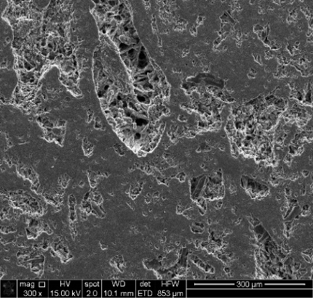
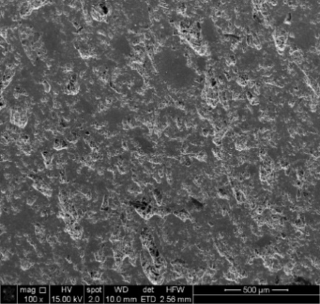
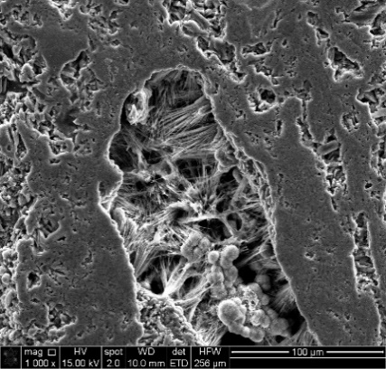
(a)
(b)
(c)
Figure 3— SEM images of Ferrierite samples polished and carbon coated: (a) Low magnification image of Ferrierite at 100x; (b) Higher magnification at 300x; (c) High magnification image at 1000x showing the ferrierite crystal networks with arrows pointing at spherical aggregates characteristic of Ferrierite.
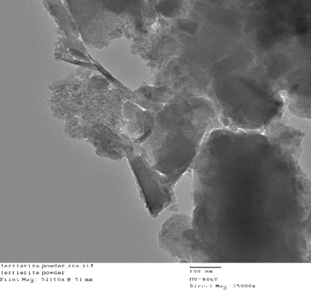
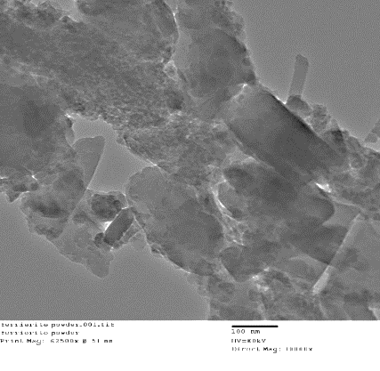
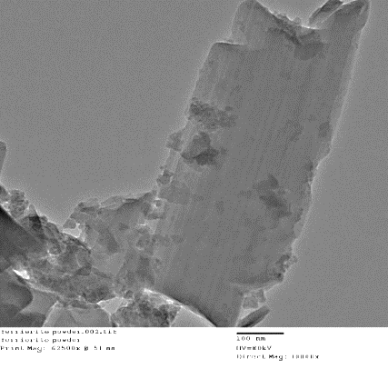

FER-Mg
Ort
Ort
(a)
(b)
(c)
Figure 4— TEM micrographs of Ferrierite samples Highlighting the various morphological features of the as-received untreated Ferrierite powder. (a) Diverse morphology of finely ground Ferrierite at 25000x; (b) Different crystal phases – Spherical aggregates typical of Ferrierite-Mg (FER-Mg) as well as orthorhombic (Ort) phases observed in finely ground Ferrierite at 30000x; (c) Orthorhombic crystals observed in finely ground Ferrierite at 30000x under TEM

The EDS results obtained for the chemically treated ferrierite had shown a variation in the atomic percentages of the various elements present in it. These variations could be related to the interactions of ferrierite with these chemical solutions. However, since these are natural materials, some chemical variations are to be expected due to chemical impurities, except where it is clear the reacting fluid is a cause of change, as in case of Ca(OH)₂.

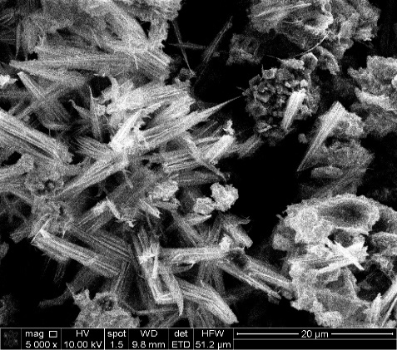
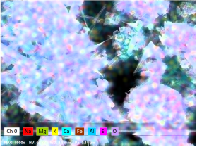
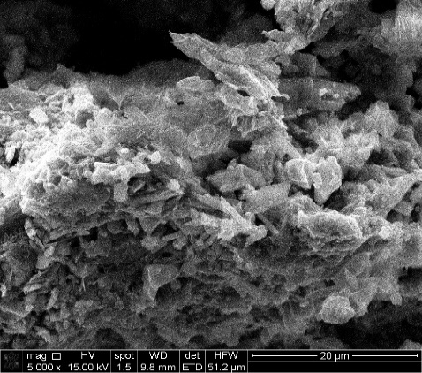
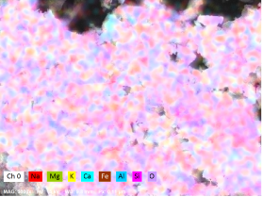
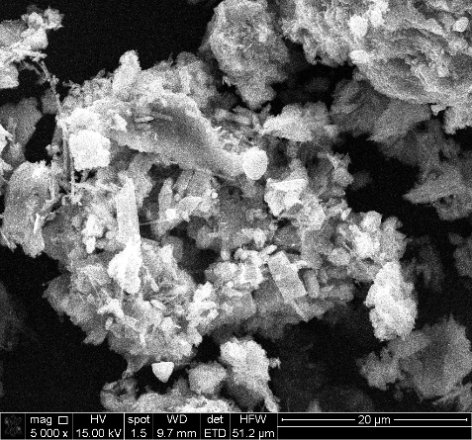
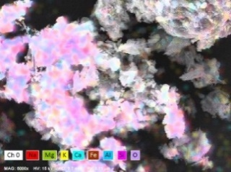
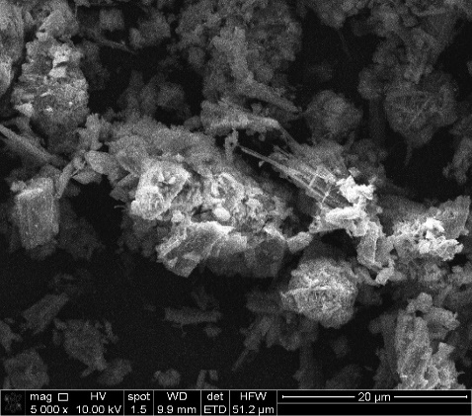
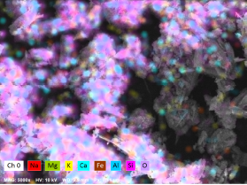
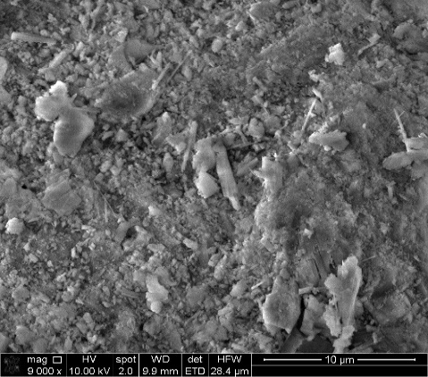
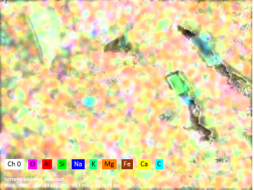
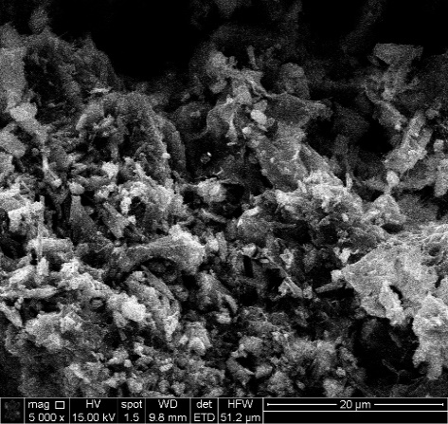
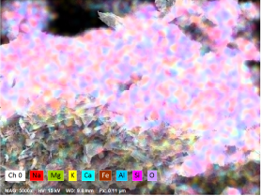
(c)
(d)
(e)
(b)
(a)
(f)

Figure 5— SEM images with their respective EDS maps at 5000x (a) Plain ferrierite (Control); (b) ferrierite in HCl; (c) ferrierite in Ca(OH)₂; (d) ferrierite in NaCl; (e) ferrierite in DI Water, (f) ferrierite in oil.
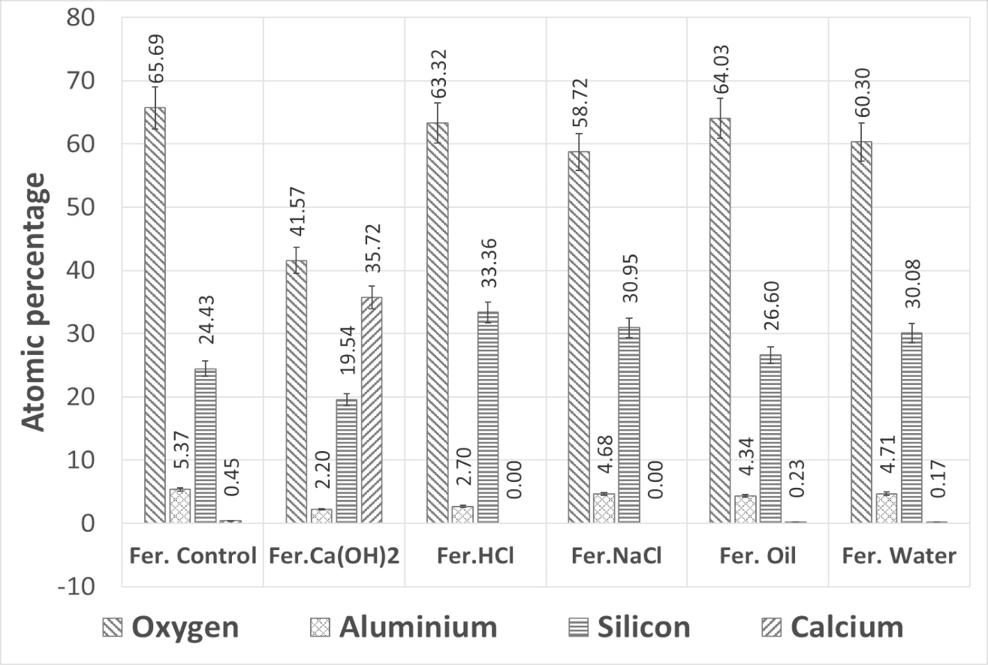
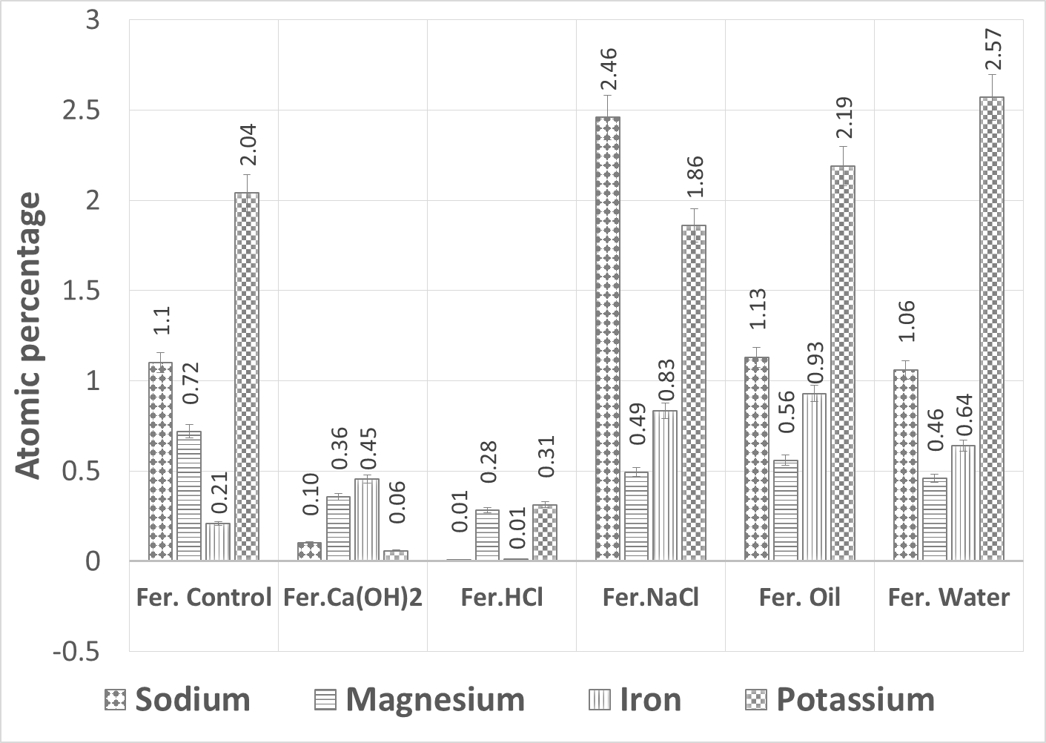
Figure 6— EDS analysis focusing on changes in O, Al, Si and Ca, after exposing finely powdered Ferrierite to DI water, high and low pH aqueous solutions, brine and synthetic oil at 90˚C for one week. Ca-rich deposits depleted in Si are observed after contact with high pH solution are most notable and relevant due similarity to Portland cement hydration.

After completing the chemical sensitivity test and showing the results using EDS and the change of elemental composition in terms of percentage, ferrierite was tested for phase changes, if any, using XRD. The phases observed as peaks in the XRD study correspond to the peaks of ferrierite-Mg as identified from the ICDD (International center for Diffraction data) database.
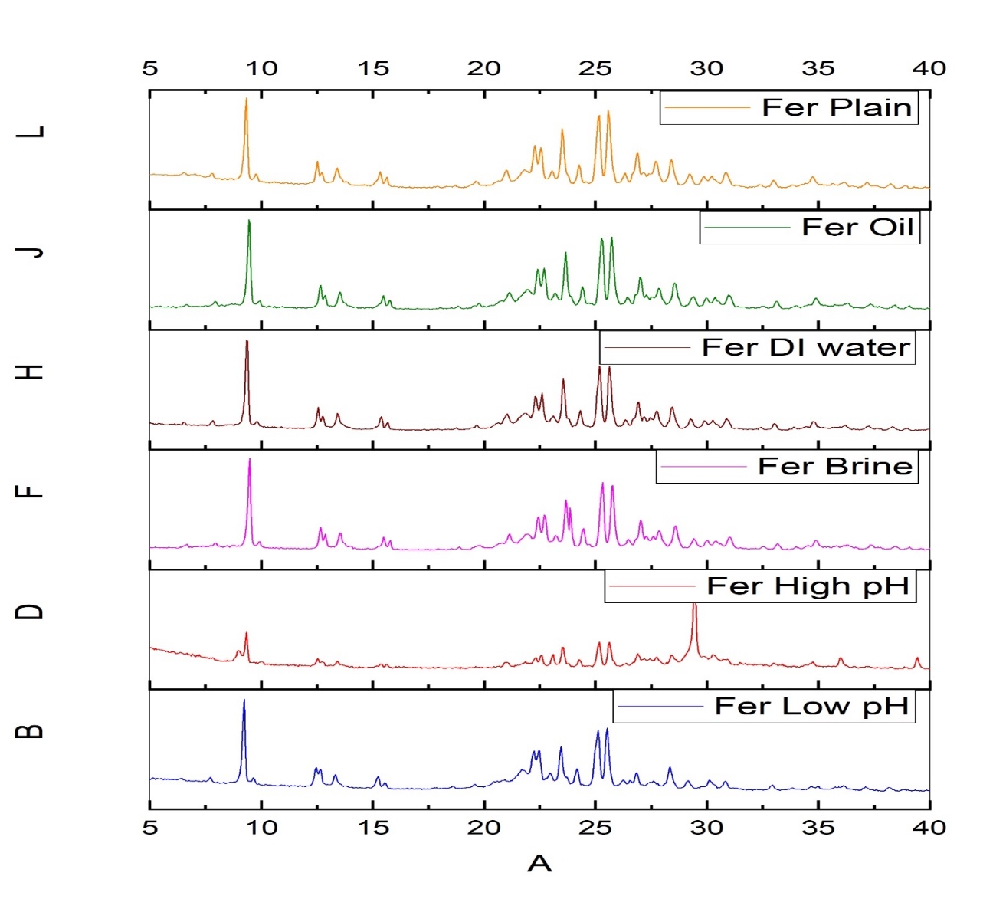
25.1951
25.5204
9.2256

Figure 7— XRD data of ferrierite powder after exposure to DI water, high and low pH aqueous solutions, brine and synthetic oil at 90˚C for one week, compared with the control sample. Standard ferrierite peaks are highlighted. We observe that the control or the plain Ferrierite sample shows the same peaks as standard Ferrierite-Mg. All, but Ca(OH)₂ exposed sample, of the post-exposure samples do the same indicating that there is no phase change in the mineral after exposure to simulated sub-surface chemical conditions. In case of high alkalinity solution, the Ferrierite peaks are reduced and new peaks are observed, confirming EDS data, pointed by red arrow.

This data would indicate the chemically stable nature of ferrierite which would lead to our hypothesis that the Ferrierite would be acting more as a scaffolding structure for hydration to take place rather than directly taking part in the hydration reaction as a chemical additive. To support this hypothesis, the results also include SEM images of fractured areas of the Earlier mentioned zeolite cement cores prepared from the 16 PPG slurries that were developed. These observations show the unreacted Ferrierite crystals which were observed in the cement matrix as well as morphological features indicating a possible self-healing nature of these cements on addition of ferrierite.
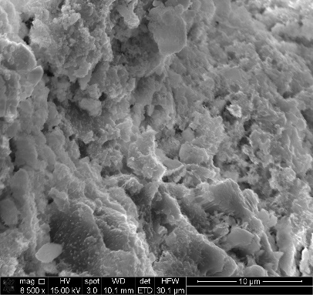
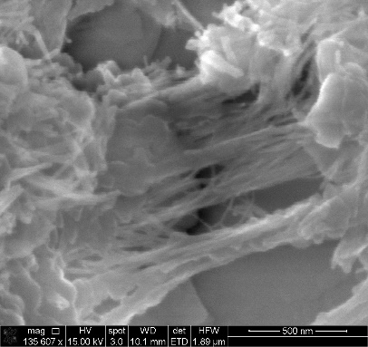
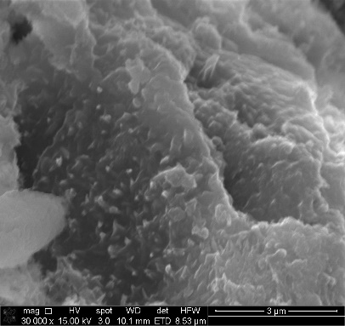
(a)
(b)
Figure 8— Fractured zeolite cement core samples clearly showing features like (a) Newly hydrated crystals at 30,000x magnification under SEM and (b) Secondary hydration suggesting possible self-healing properties seen at 135,607x magnification under SEM.
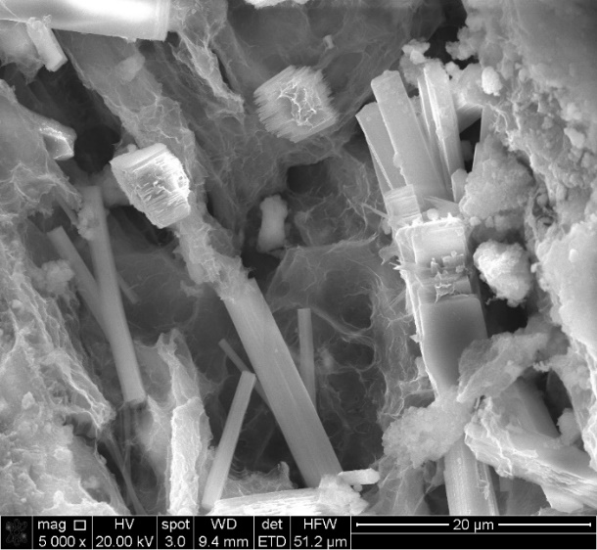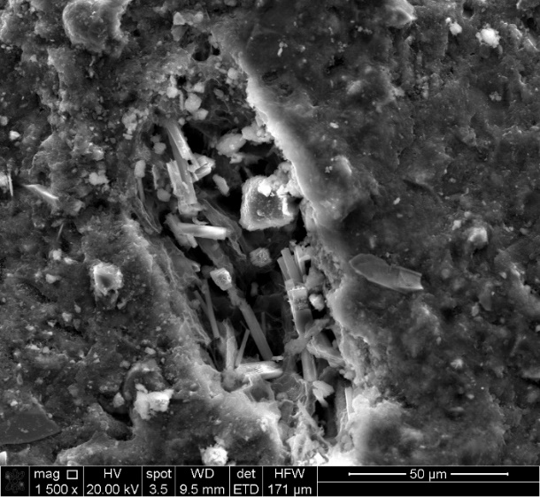
(b)
(a)
Figure 9— Unreacted Ferrierite observed in pore spaces within the cement matrix of polished zeolite cement core. (a) A pore on the cement surface of a polished zeolite cement core observed at 1500x magnification (b) Ferrierite crystals observed at 5000X magnification.

CT scans of the initial test slurry designs were performed to see how the trial cores of 16 PPG zeolite cement cores looked. It was observed that these cores contained microfractures and hence it was concluded that this formulation could not be used as is for comparison with Class-H cores with ferrierite additions which would be made in order to test for plugging and abandonment purposes. Below are the CT scan images of the trial 16 PPG zeolite cement cores.
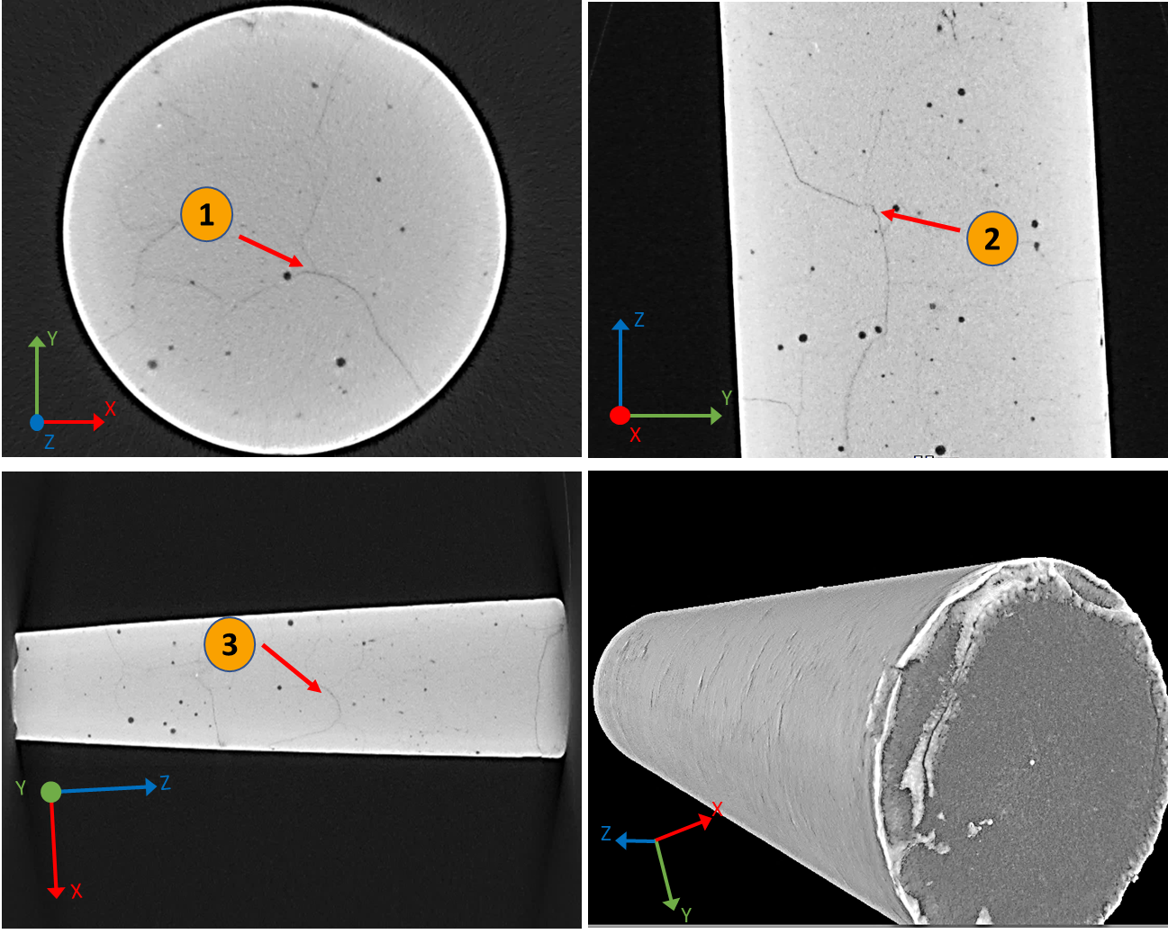
Figure 10— CT scan images of trial 16 PPG zeolite cement test slurry cores showing microfractures.

Due to presence of microfractures, this slurry design was considered as unqualified for our test purposes. The new slurry design which was then developed was tested later and Figures 8&9 correspond to the cores from that slurry design. Once the correct slurry was made, the resultant cores were selected as the base case for comparison with the ferrierite mixed cement slurries which are described below.

To further support the advantages of zeolite addition, cement slurries are made with 5%, 15% and 30% additions of Ferrierite. Currently the studies are underway to Show the material properties using tools like SEM, EDS , Raman and XRD. Below is the XRD data of 16 PPG zeolite cement compared to 30% Ferrierite added class-H cement to show the similarity of phases between both showing initial success in developing a Ferrierite added formulation with Class-H.
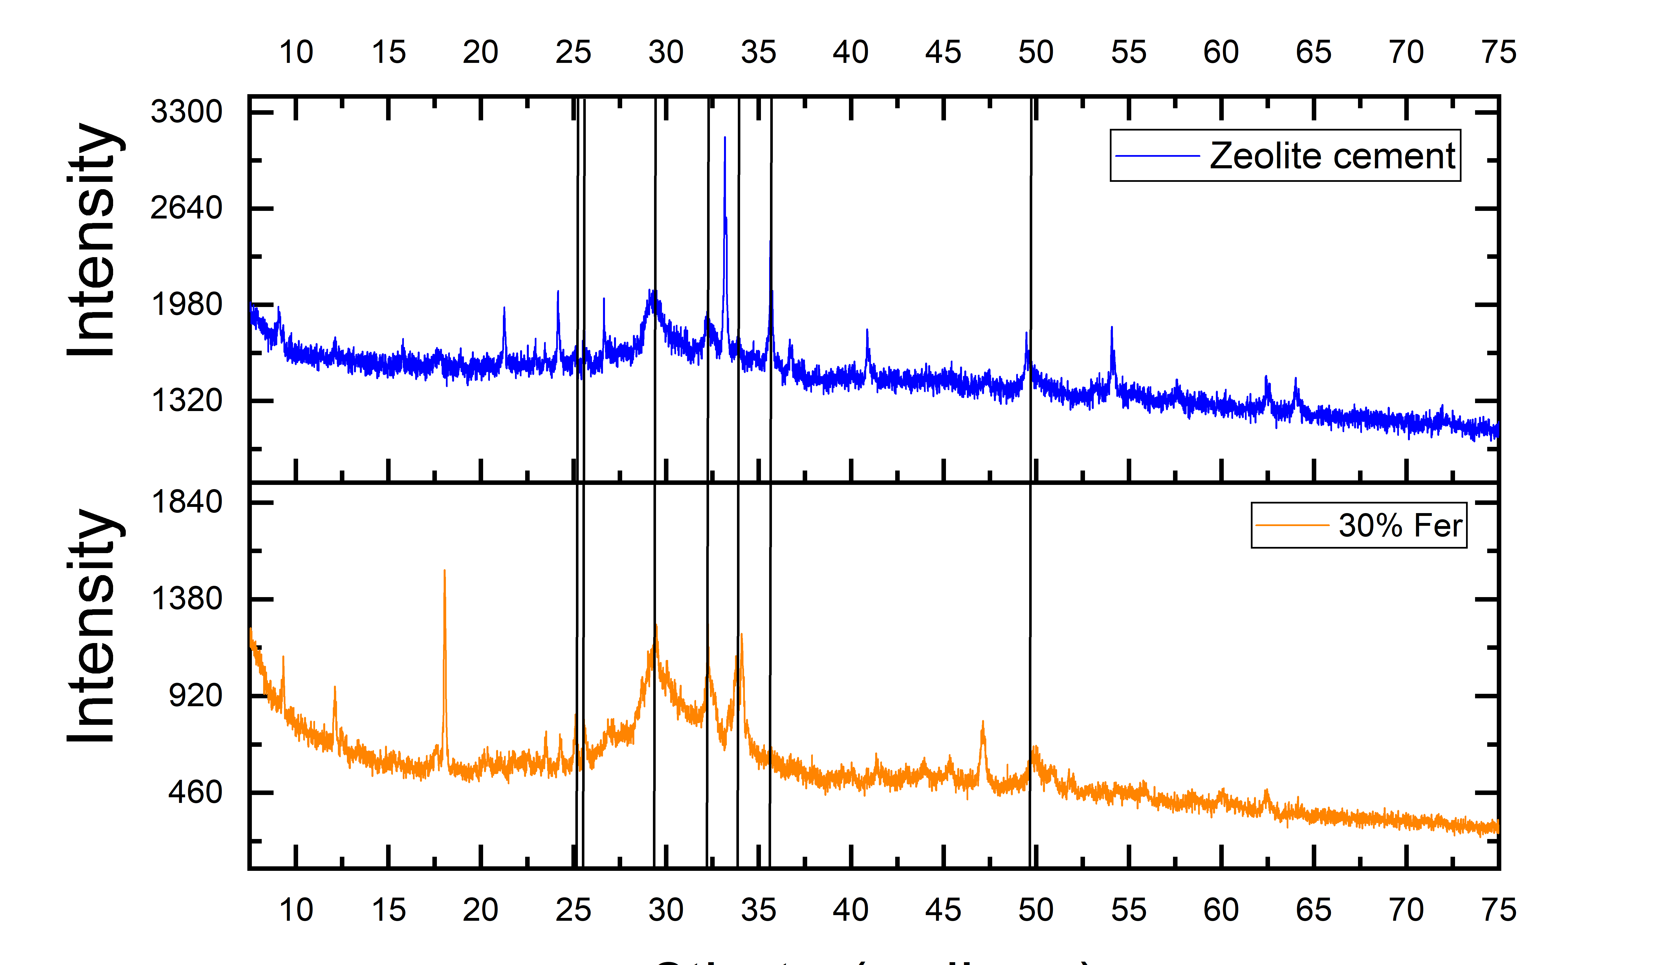
CH
CSH
CH
C₃S
CSH
Fer
Fer
Figure 11— XRD results showing similarity of phases between 16 PPG zeolite cement and 30% Ferrierite added class-H cement suggesting the initial success of Class-H cement design with ferrierite additions.

The cement cores that were obtained from the slurry designs with 5%, 15%, and 30% additions of this zeolite were also tested for unconfined compressive strength (UCS) and were compared to neat Class-H cement. It was noted that 5% addition of Ferrierite had shown a substantial increase in the UCS supporting the data from the literature that zeolite additions showed an increase in the strength properties. The UCS tests were performed as noted in the materials and methods section earlier in this paper. The data was acquired as follows. The table below shows the dimensions, namely diameter (inches) and length (inches) of the cores tested, the axial load calculated in Kn, UCS in psi and MPa units, measured mass of cores in grams, calculated density (grams/cc), and calculated aspect ratio of the cores. The aspect ratio of the cores taken for these tests were approximately those of the ASTM standards i.e., 2:1 aspect ratio. The specific strength enhancement of the cement on addition of 5% ferrierite is yet to be studied in detail but the current scope of this paper is limited to showing the property enhancement on addition of zeolites (ferrierite) in the said percentages. This UCS data helps to observe and support the hypothesis which was made based on the studies from the literature and we partially succeed in verifying the same.

S.No | Sample | Diameter | Length | Axial load | UCS | UCS | Mass | Density
S.No | Sample | in | in | Kn | psi | MPa | grams | grams/cc
1 | 5% Ferrierite 1 | 1.001 | 1.950 | 34.676 | 9,906 | 68.30 | 49.680 | 1.976
2 | 5% Ferrierite 2 | 1.001 | 1.948 | 35.499 | 10,141 | 69.92 | 49.767 | 1.981
3 | 5% Ferrierite 3 | 0.999 | 1.915 | 33.981 | 9,756 | 67.26 | 48.657 | 1.980
4 | 15% Ferrierite 1 | 0.991 | 1.950 | 22.857 | 6,662 | 45.93 | 48.436 | 1.965
5 | 15% Ferrierite 2 | 0.997 | 1.930 | 23.681 | 6,826 | 47.06 | 49.106 | 1.991
6 | 15% Ferrierite 3 | 0.991 | 1.919 | 22.169 | 6,468 | 44.59 | 47.702 | 1.969
7 | 30% Ferrierite 1 | 0.997 | 1.940 | 22.184 | 6,388 | 44.05 | 46.255 | 1.864
8 | 30% Ferrierite 2 | 1.001 | 1.960 | 22.039 | 6,296 | 43.41 | 46.936 | 1.857
9 | 30% Ferrierite 3 | 0.999 | 1.909 | 21.850 | 6,273 | 43.25 | 45.368 | 1.853
10 | Neat class-H 1 | 1.198 | 1.984 | 35.623 | 7,111 | 49.03 | 74.111 | 2.024
11 | Neat class-H 2 | 1.197 | 1.934 | 35.192 | 7,030 | 48.47 | 71.784 | 2.013
12 | Neat class-H 3 | 1.199 | 1.973 | 35.045 | 6,984 | 48.15 | 73.769 | 2.022

Table 2— UCS data acquired for the cement cores made from the slurries with 5%, 15% and 30% percentages by weight of ferrierite additions, compared to the neat class-H cement cores with 0% ferrierite addition.

It was shown from the above data that 5% ferrierite addition had shown a substantial increase in the UCS as compared to the neat cement and higher additions of the ferrierite. 3 sample cores of each slurry design were taken to get an average value. As each set of the sample cores were from the same batch, they showed consistency in the UCS measurements and they were averaged to get a sample UCS for each slurry design. While neat class-H cement showed an average UCS of 7041psi, 15% and 30% showed 6652psi and 6319psi respectively, 5% addition had shown 9934.3psi which is a 41% increase in UCS compared to the neat class-H cement. This increase in UCS can clearly be attributed to the ferrierite addition and further studies are underway to understand the mechanism in which this zeolite impacts cement.

Discussion:

The elemental and morphological analysis shows that these zeolites are slightly affected by these tests in terms of the surface elemental composition but retained the aluminosilicate networks. The addition of Ca(OH)₂ had shown formation of CH crystals in the SEM micrographs. Though the EDS results show a change in the composition, the XRD results remain the same showing peaks prominently corresponding to ferrierite. This shows that there is no phase change observed that reinforces the fact that ferrierite is not hydraulic in nature and the retention of phases would be favorable for cement during hydration. It can still act as a scaffolding structure providing a substrate for the hydration to take place. This synergistic nature of zeolite could be the strongest reason for considering ferrierite as a supplementary cementitious material that will not interfere with cement hydration directly but would provide morphological template for CSH. The Ferrierite crystals observed in zeolite cement cores support our hypothesis that the zeolite acts as a scaffolding for hydration reaction to take place. Also, the possibility of self-healing capabilities makes it a potential candidate to be further studied as an addition to wellbore cement for high temperature and high-pressure applications, since zeolites exhibit stability under hydrothermal conditions. The XRD results and the EDS results of plain zeolite after the sensitivity studies in different chemical conditions support the hypothesis. The XRD results shown at the end of the results section suggest the partial success in adapting the commercially available low-density zeolite cement to a new ferrierite added formulation for plugging and abandonment purposes. The similarity in the phases observed in both the formulations show that they are of the same chemical nature. Observing the ferrierite peaks in both cases shows the chemically stable nature of that zeolite on addition to cement. The UCS data obtained comparing the 5%, 15% 30% ferrierite added cements and neat cement show a clear increase in the strength characteristics. This shows that the zeolite that we had chosen for our studies is a correct fit and would in future help us create a robust barrier plugging material. However, a lot of research is yet to be done to understand the mechanism of this zeolite additions and it would be studied in our future work. The usage of tools like Raman, SEM and EDS analysis coupled with XRD would make a considerable addition to our research and are currently under progress.

Conclusions

Based on the observations, it is a safe choice to use ferrierite as a supplementary cementitious material. Like all other zeolites observed in the literature, ferrierite showed morphological characteristics like cement phases which would act as a scaffolding structure or substrate for the cement hydration to take place. This would add to the hydration of cement by homogeneously being a part of the cement phases. Zeolite showed slight changes in the surface elemental compositions on exposure to Ca(OH )₂ and HCl. CH crystals had been observed in the samples exposed to Ca(OH)₂. The iron content was found to be the lowest in samples exposed to HCl. Despite these changes in the surface elemental compositions, the XRD results indicate that there are no changes in the phases which reinforces the non-hydraulic nature of ferrierite and its stability when exposed to sub-surface chemical conditions. With these considerations, ferrierite can be chosen as a supplementary cementitious material. XRD results of the cement formulations indicate the initial success in developing a formulation for P&A. Future work is planned to study the effect of the addition of this zeolite to Class-H cement in various compositions and studying their properties. Current UCS data supports initial claims of the work and future studies are planned for Triaxial tests, Indentation and the relevant strength tests. Further work would include the petrophysical analysis of properties like porosity and permeability which are one of the primary concerns of an ideal barrier material. The ultimate goal of this research would be understanding the working mechanism of this zeolite in cement

Acknowledgements

This research has been funded by the National Academy of Science Engineering and Medicine Gulf of Mexico program (NASEM-GRP) grant #10002358. Thanks are due to the G. Trabits, of Trabits group, for providing zeolite samples and also the commercial zeolite cement formulation. We thank L. Leotaud from NexTier oilfield solution for help with developing the 16PPG zeolite cement slurries, and also for critical review and insights in writing the paper. Special thanks to B. Johnson and L. Whitworth from the Oklahoma State Microscopy Center whose support had been indispensable. Sincere thanks to Eric Cline from Chesapeake energy for their support in acquiring the UCS data of the cement cores. Last but not the least we would like to thank our members for their continuous support during the course of this work: Cody, Allan, Canaan, Mercy, Guofan and Lashell.

References:

1. Brady, S., et al. Recent technological advances help solve cement placement problems in the Gulf of Mexico. in SPE/IADC Drilling Conference. 1992. Society of Petroleum Engineers.
2. Vrålstad, T., et al., Plug & abandonment of offshore wells: Ensuring long-term well integrity and cost-efficiency. Journal of Petroleum Science and Engineering, 2019. 173: p. 478-491.
3. Herndon, J. and D.K. Smith, Plugging wells for abandonment: a state-of-the-art study and recommended procedures. 1976, Halliburton Services, Duncan, OK (USA).
4. Calvert, D. and D.K. Smith. Issues and techniques of plugging and abandonment of oil and gas wells. in SPE Annual Technical Conference and Exhibition. 1994. Society of Petroleum Engineers.
5. Rassenfoss, S., Permanently plugging deepwater wells challenges standard operating procedures. Journal of Petroleum Technology, 2014. 66(12): p. 52-60.
6. Siddique, R. and D. Kaur, Properties of concrete containing ground granulated blast furnace slag (GGBFS) at elevated temperatures. Journal of Advanced Research, 2012. 3(1): p. 45-51.
7. Nili, M. and A. Ehsani, Investigating the effect of the cement paste and transition zone on strength development of concrete containing nanosilica and silica fume. Materials & Design, 2015. 75: p. 174-183.
8. Wild, S., J.M. Khatib, and A. Jones, Relative strength, pozzolanic activity and cement hydration in superplasticised metakaolin concrete. Cement and concrete research, 1996. 26(10): p. 1537-1544.
9. Bijen, J., Benefits of slag and fly ash. Construction and Building Materials, 1996. 10(5): p. 309-314.
10. Chindaprasirt, P., C. Jaturapitakkul, and T. Sinsiri, Effect of fly ash fineness on compressive strength and pore size of blended cement paste. Cement and Concrete Composites, 2005. 27(4): p. 425-428.
11. Langan, B.W., K. Weng, and M.A. Ward, Effect of silica fume and fly ash on heat of hydration of Portland cement. Cement and Concrete Research, 2002. 32(7): p. 1045-1051.
12. Poon, C., et al., A study on the hydration rate of natural zeolite blended cement pastes. Construction and Building Materials, 1999. 13(8): p. 427-432.
13. Chen, J., et al., Effects of superfine zeolite on strength, flowability and cohesiveness of cementitious paste. Cement and Concrete Composites, 2017. 83: p. 101-110.
14. Ahmadi, B. and M. Shekarchi, Use of natural zeolite as a supplementary cementitious material. Cement and Concrete Composites, 2010. 32(2): p. 134-141.
15. Feng, N.-Q., G.-Z. Li, and X.-W. Zang, High-strength and flowing concrete with a zeolitic mineral admixture. Cement, concrete and aggregates, 1990. 12(2): p. 61-69.
16. Lilkov, V., et al., Study of the pozzolanic activity and hydration products of cement pastes with addition of natural zeolites. Clay minerals, 2011. 46(2): p. 241-250.
17. Perraki, T., G. Kakali, and F. Kontoleon, The effect of natural zeolites on the early hydration of Portland cement. Microporous and Mesoporous Materials, 2003. 61(1-3): p. 205-212.
18. Valipour, M., et al., Comparing a natural pozzolan, zeolite, to metakaolin and silica fume in terms of their effect on the durability characteristics of concrete: A laboratory study. Construction and Building Materials, 2013. 41: p. 879-888.
19. Markiv, T., et al., Mechanical and durability properties of concretes incorporating natural zeolite. Archives of Civil and Mechanical Engineering, 2016. 16(4): p. 554-562.
20. Pyatina, T., et al., Self-repairing properties of OPC clinker/natural zeolite blend in water and alkali carbonate environments at 270°C. Advances in Cement Research, 2018. 30(1): p. 8-23.
21. Rice, S.B., K.G. Papke, and D.E. Vaughan, Chemical controls on ferrierite crystallization during diagenesis of silicic pyroclastic rocks near Lovelock, Nevada. American Mineralogist, 1992. 77(3-4): p. 314-328.
22. Pacewska, B., et al., Effect of waste aluminosilicate material on cement hydration and properties of cement mortars. Cement and Concrete Research, 2002. 32(11): p. 1823-1830.
23. Najimi, M., et al., An experimental study on durability properties of concrete containing zeolite as a highly reactive natural pozzolan. Construction and Building Materials, 2012. 35: p. 1023-1033.
24. Nagrockiene, D. and G. Girskas, Research into the properties of concrete modified with natural zeolite addition. Construction and Building Materials, 2016. 113: p. 964-969.
25. LaRosa, J.L., S. Kwan, and M.W. Grutzeck, Zeolite formation in class F fly ash blended cement pastes. Journal of the American Ceramic Society, 1992. 75(6): p. 1574-1580.
26. Shahrabadi, H., S. Sayareh, and H. Sarkardeh, Effect of Natural Zeolite-Pozzolan on Compressive Strength of Oil-Polluted Concrete Marine Structures. Civil Engineering Journal, 2017. 2(12).
27. Mola-Abasi*, H. and I. Shooshpasha, Influence of zeolite and cement additions on mechanical behavior of sandy soil. Journal of Rock Mechanics and Geotechnical Engineering, 2017. 9(1): p. 170-179.
28. Ahn, T.-H. and T. Kishi, Crack self-healing behavior of cementitious composites incorporating various mineral admixtures. Journal of Advanced Concrete Technology, 2010. 8(2): p. 171-186.
29. Su, Y.-F., et al., Autogenous healing performance of internal curing agent-based self-healing cementitious composite. Cement and Concrete Composites, 2020. 114: p. 103825.
30. Tran, Y.T., et al., Natural zeolite and its application in concrete composite production. Composites Part B: Engineering, 2019. 165: p. 354-364.
31. Sičáková, A., et al., Long-term properties of cement-based composites incorporating natural zeolite as a feature of progressive building material. Advances in Materials Science and Engineering, 2017. 2017.

