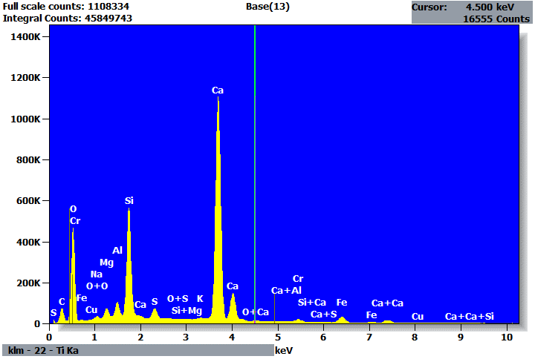

Quantitative Results for: Base(13)
Element | Net  Counts | Int.  Cps/nA | Weight % | Atom %
C | 712163 | --- | 4.61 | 8.29
O | 3670019 | --- | 46.33 | 62.53
Na | 117638 | --- | 0.41 | 0.39
Mg | 476249 | --- | 1.10 | 0.98
Al | 729479 | --- | 1.29 | 1.04
Si | 5989932 | --- | 9.49 | 7.30
S | 777965 | --- | 1.11 | 0.75
K | 93873 | --- | 0.16 | 0.09
Ca | 15961039 | --- | 32.28 | 17.39
Cr | 176764 | --- | 0.68 | 0.28
Fe | 486626 | --- | 2.43 | 0.94
Cu | 11661 | --- | 0.10 | 0.03
Total |  |  | 100.00 | 100.00

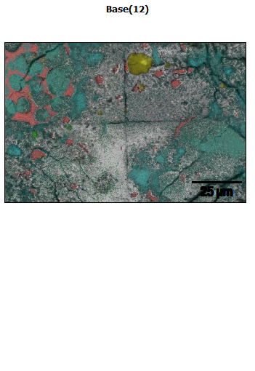
Data Type: Counts
Image Resolution: 512 by 340
Image Pixel Size: 0.24 µm
Map Resolution: 512 by 340
Map Pixel Size: 0.24 µm
Acc. Voltage: 20.0 kV
Magnification: 1750
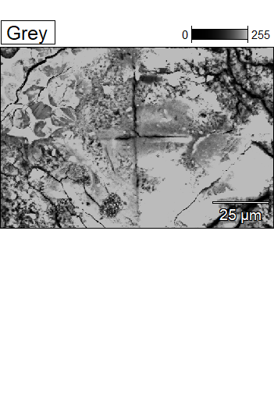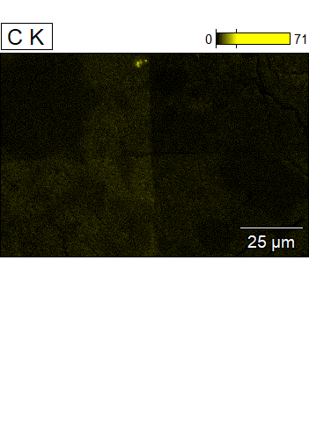

Data Type: Counts
Image Resolution: 512 by 340
Image Pixel Size: 0.24 µm
Map Resolution: 512 by 340
Map Pixel Size: 0.24 µm
Acc. Voltage: 20.0 kV
Magnification: 1750
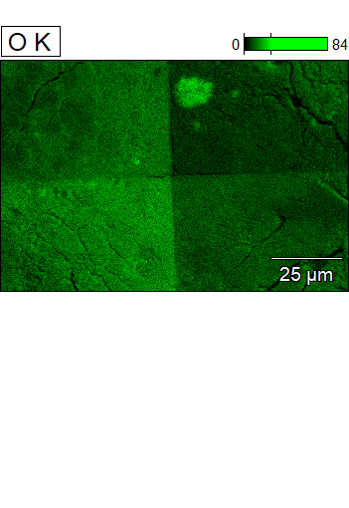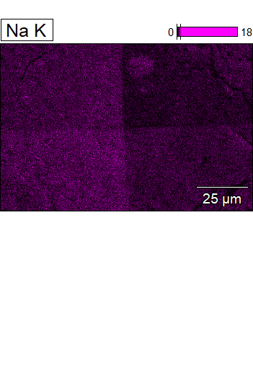

Data Type: Counts
Image Resolution: 512 by 340
Image Pixel Size: 0.24 µm
Map Resolution: 512 by 340
Map Pixel Size: 0.24 µm
Acc. Voltage: 20.0 kV
Magnification: 1750
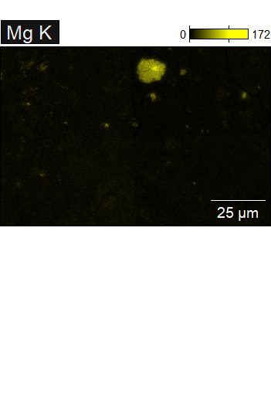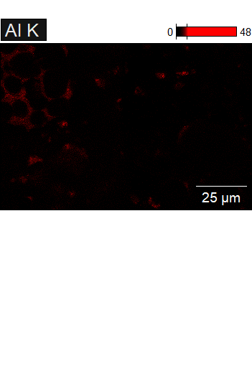

Data Type: Counts
Image Resolution: 512 by 340
Image Pixel Size: 0.24 µm
Map Resolution: 512 by 340
Map Pixel Size: 0.24 µm
Acc. Voltage: 20.0 kV
Magnification: 1750
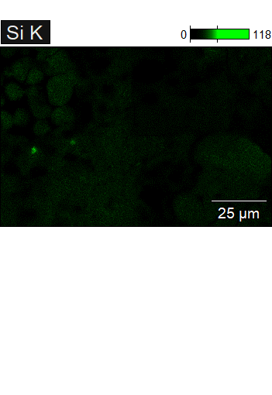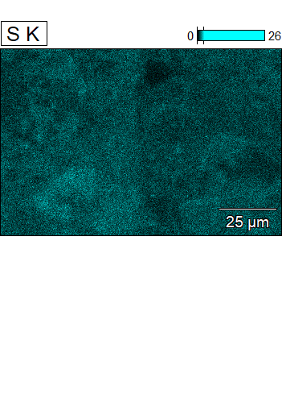

Data Type: Counts
Image Resolution: 512 by 340
Image Pixel Size: 0.24 µm
Map Resolution: 512 by 340
Map Pixel Size: 0.24 µm
Acc. Voltage: 20.0 kV
Magnification: 1750
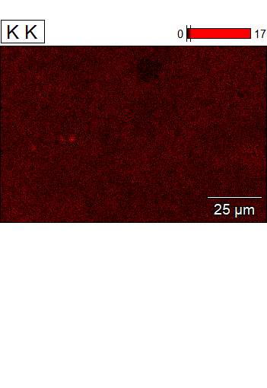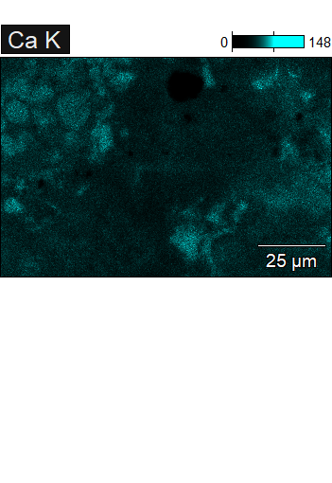

Data Type: Counts
Image Resolution: 512 by 340
Image Pixel Size: 0.24 µm
Map Resolution: 512 by 340
Map Pixel Size: 0.24 µm
Acc. Voltage: 20.0 kV
Magnification: 1750
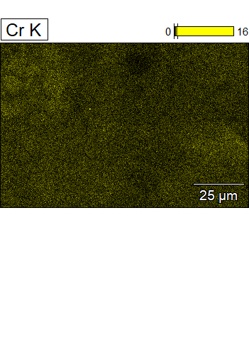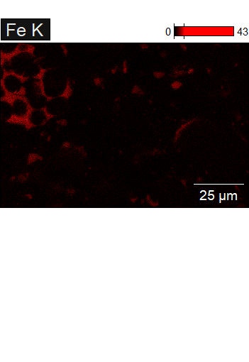

Data Type: Counts
Image Resolution: 512 by 340
Image Pixel Size: 0.24 µm
Map Resolution: 512 by 340
Map Pixel Size: 0.24 µm
Acc. Voltage: 20.0 kV
Magnification: 1750
