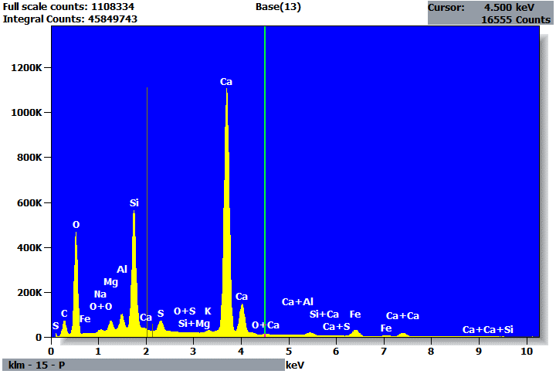

Quantitative Results for: Base(13)
Element | Net  Counts | Int.  Cps/nA | Weight % | Atom %
C | 711835 | --- | 4.46 | 7.90
O | 4002101 | --- | 48.28 | 64.24
Na | 129916 | --- | 0.44 | 0.41
Mg | 480650 | --- | 1.08 | 0.95
Al | 729086 | --- | 1.26 | 1.00
Si | 5989252 | --- | 9.26 | 7.02
S | 777962 | --- | 1.08 | 0.72
K | 93873 | --- | 0.16 | 0.09
Ca | 15961039 | --- | 31.55 | 16.76
Fe | 496971 | --- | 2.42 | 0.92
Total |  |  | 100.00 | 100.00

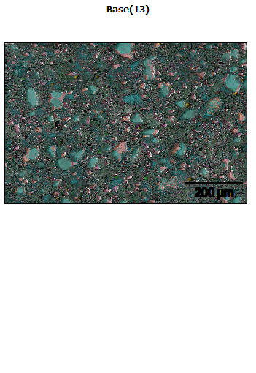
Data Type: Counts
Image Resolution: 512 by 340
Image Pixel Size: 1.68 µm
Map Resolution: 512 by 340
Map Pixel Size: 1.68 µm
Acc. Voltage: 20.0 kV
Magnification: 250
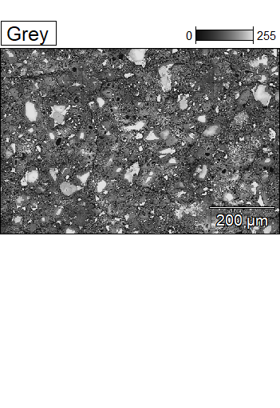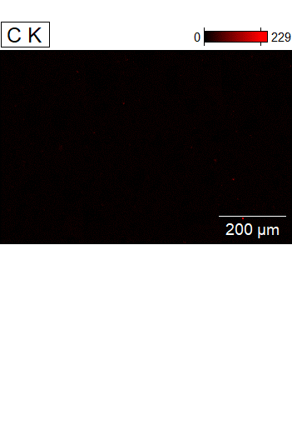

Data Type: Counts
Image Resolution: 512 by 340
Image Pixel Size: 1.68 µm
Map Resolution: 512 by 340
Map Pixel Size: 1.68 µm
Acc. Voltage: 20.0 kV
Magnification: 250
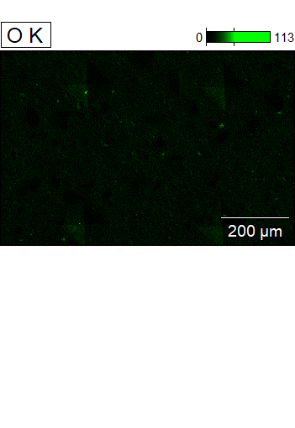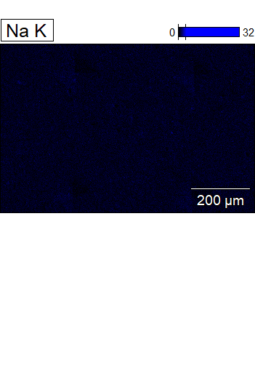

Data Type: Counts
Image Resolution: 512 by 340
Image Pixel Size: 1.68 µm
Map Resolution: 512 by 340
Map Pixel Size: 1.68 µm
Acc. Voltage: 20.0 kV
Magnification: 250
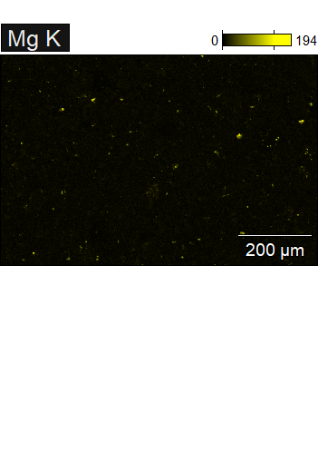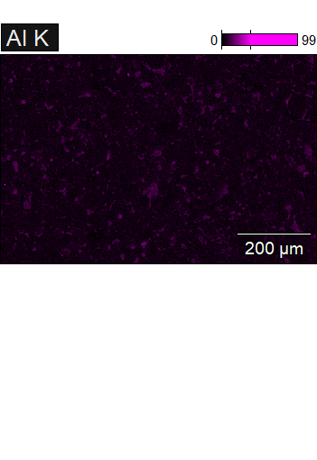

Data Type: Counts
Image Resolution: 512 by 340
Image Pixel Size: 1.68 µm
Map Resolution: 512 by 340
Map Pixel Size: 1.68 µm
Acc. Voltage: 20.0 kV
Magnification: 250
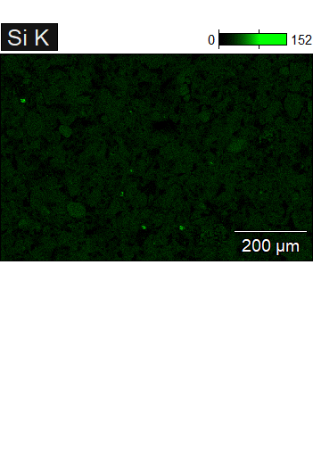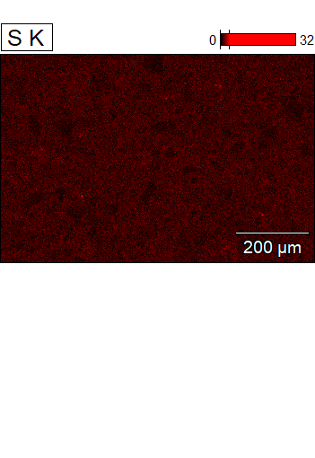

Data Type: Counts
Image Resolution: 512 by 340
Image Pixel Size: 1.68 µm
Map Resolution: 512 by 340
Map Pixel Size: 1.68 µm
Acc. Voltage: 20.0 kV
Magnification: 250
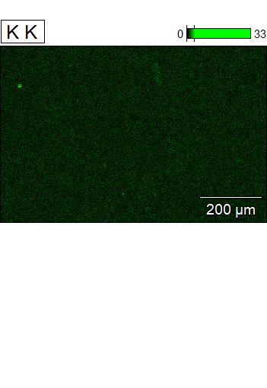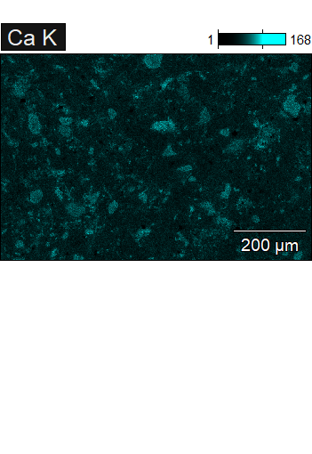

Data Type: Counts
Image Resolution: 512 by 340
Image Pixel Size: 1.68 µm
Map Resolution: 512 by 340
Map Pixel Size: 1.68 µm
Acc. Voltage: 20.0 kV
Magnification: 250
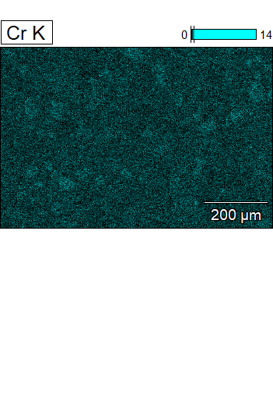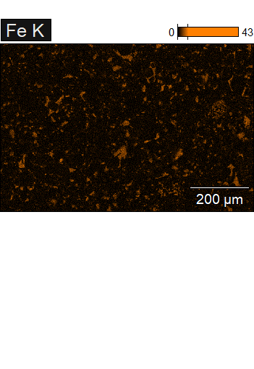

Data Type: Counts
Image Resolution: 512 by 340
Image Pixel Size: 1.68 µm
Map Resolution: 512 by 340
Map Pixel Size: 1.68 µm
Acc. Voltage: 20.0 kV
Magnification: 250
