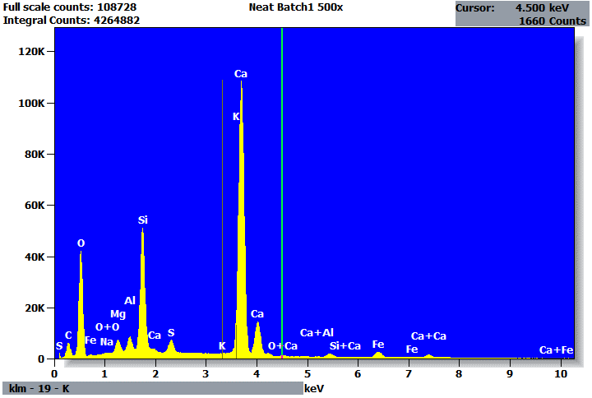

Quantitative Results for: Neat Batch1 500x
Element | Net  Counts | Int.  Cps/nA | Weight % | Atom %
C | 59507 | --- | 3.98 | 7.09
O | 365195 | --- | 48.70 | 65.04
Na | 4516 | --- | 0.17 | 0.15
Mg | 52666 | --- | 1.28 | 1.12
Al | 58013 | --- | 1.08 | 0.86
Si | 536550 | --- | 8.87 | 6.75
S | 75640 | --- | 1.12 | 0.74
K | 0 | --- | 0.00 | 0.00
Ca | 1564863 | --- | 32.75 | 17.46
Fe | 39844 | --- | 2.06 | 0.79
Total |  |  | 100.00 | 100.00

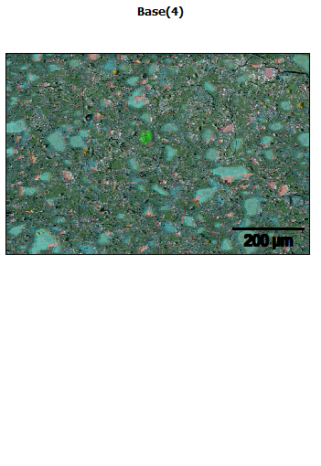
Data Type: Counts
Image Resolution: 512 by 340
Image Pixel Size: 1.68 µm
Map Resolution: 512 by 340
Map Pixel Size: 1.68 µm
Acc. Voltage: 20.0 kV
Magnification: 250
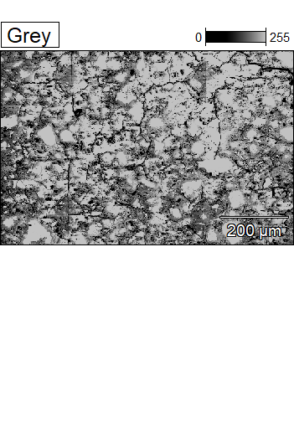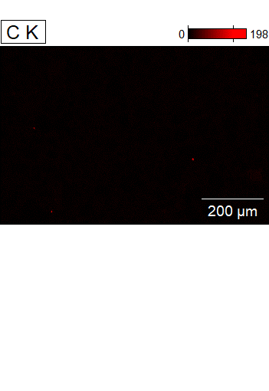

Data Type: Counts
Image Resolution: 512 by 340
Image Pixel Size: 1.68 µm
Map Resolution: 512 by 340
Map Pixel Size: 1.68 µm
Acc. Voltage: 20.0 kV
Magnification: 250
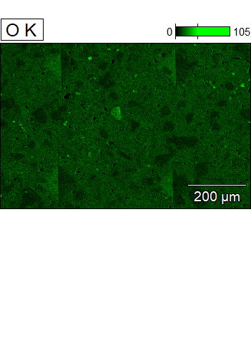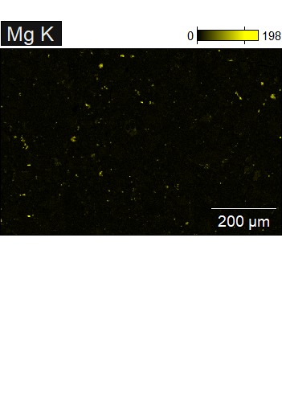

Data Type: Counts
Image Resolution: 512 by 340
Image Pixel Size: 1.68 µm
Map Resolution: 512 by 340
Map Pixel Size: 1.68 µm
Acc. Voltage: 20.0 kV
Magnification: 250
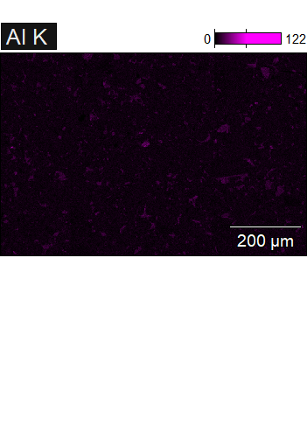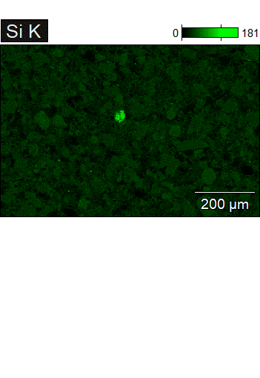

Data Type: Counts
Image Resolution: 512 by 340
Image Pixel Size: 1.68 µm
Map Resolution: 512 by 340
Map Pixel Size: 1.68 µm
Acc. Voltage: 20.0 kV
Magnification: 250
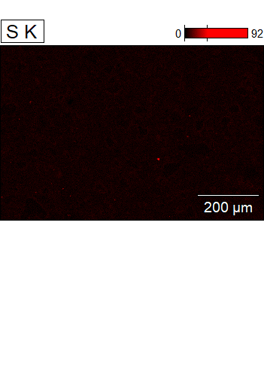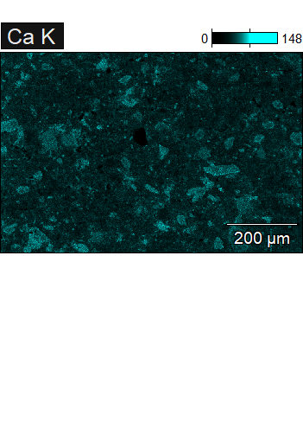

Data Type: Counts
Image Resolution: 512 by 340
Image Pixel Size: 1.68 µm
Map Resolution: 512 by 340
Map Pixel Size: 1.68 µm
Acc. Voltage: 20.0 kV
Magnification: 250
