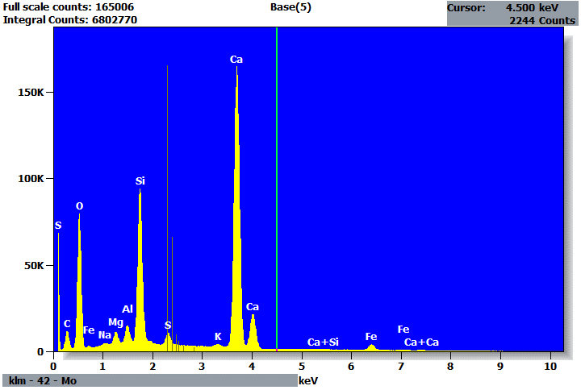

Quantitative Results for: Base(5)
Element | Net  Counts | Int.  Cps/nA | Weight % | Atom %
C | 125808 | --- | 5.04 | 8.75
O | 669471 | --- | 49.87 | 64.98
Na | 15127 | --- | 0.32 | 0.29
Mg | 74416 | --- | 1.05 | 0.90
Al | 106783 | --- | 1.16 | 0.90
Si | 1006135 | --- | 9.78 | 7.26
S | 108214 | --- | 0.95 | 0.62
K | 17467 | --- | 0.19 | 0.10
Ca | 2393183 | --- | 29.83 | 15.52
Fe | 58796 | --- | 1.80 | 0.67
Total |  |  | 100.00 | 100.00

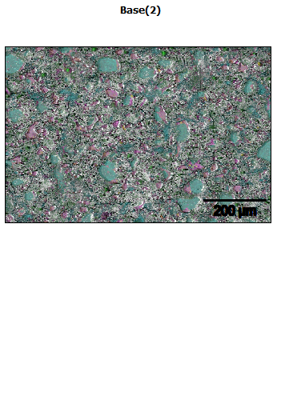
Data Type: Counts
Image Resolution: 512 by 340
Image Pixel Size: 1.68 µm
Map Resolution: 512 by 340
Map Pixel Size: 1.68 µm
Acc. Voltage: 20.0 kV
Magnification: 250
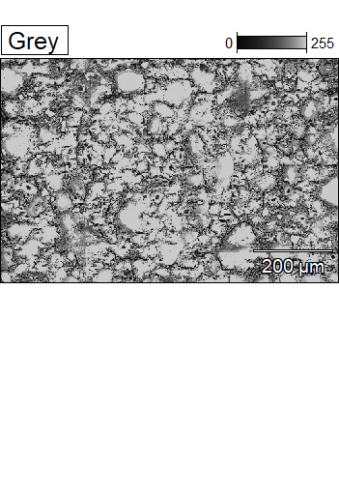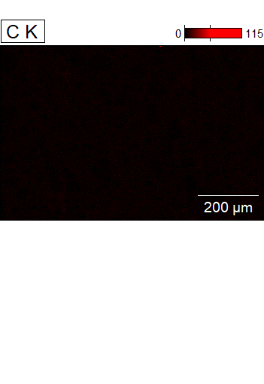

Data Type: Counts
Image Resolution: 512 by 340
Image Pixel Size: 1.68 µm
Map Resolution: 512 by 340
Map Pixel Size: 1.68 µm
Acc. Voltage: 20.0 kV
Magnification: 250
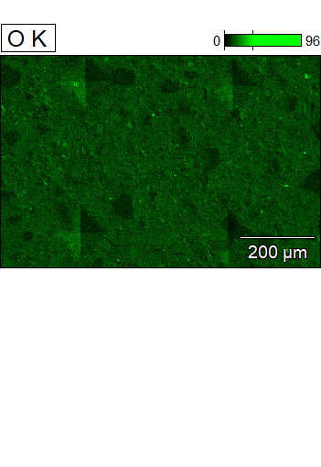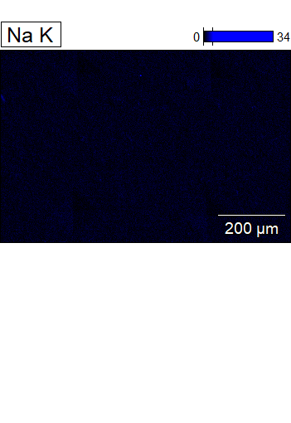

Data Type: Counts
Image Resolution: 512 by 340
Image Pixel Size: 1.68 µm
Map Resolution: 512 by 340
Map Pixel Size: 1.68 µm
Acc. Voltage: 20.0 kV
Magnification: 250
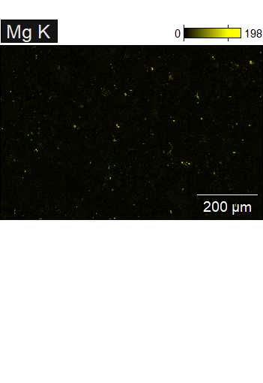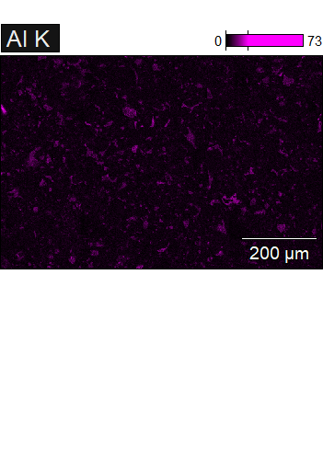

Data Type: Counts
Image Resolution: 512 by 340
Image Pixel Size: 1.68 µm
Map Resolution: 512 by 340
Map Pixel Size: 1.68 µm
Acc. Voltage: 20.0 kV
Magnification: 250
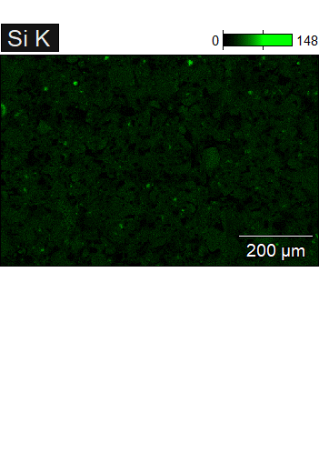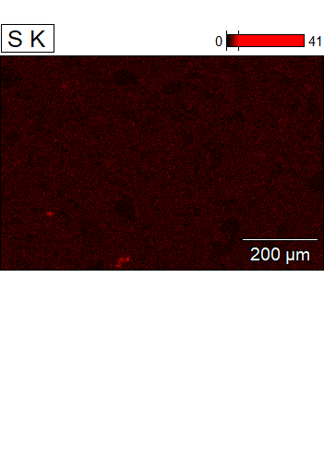

Data Type: Counts
Image Resolution: 512 by 340
Image Pixel Size: 1.68 µm
Map Resolution: 512 by 340
Map Pixel Size: 1.68 µm
Acc. Voltage: 20.0 kV
Magnification: 250
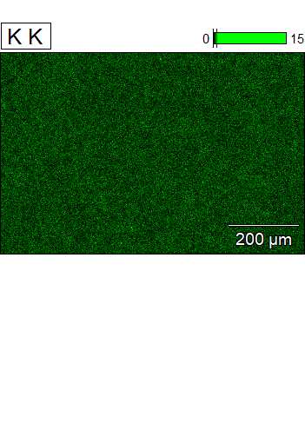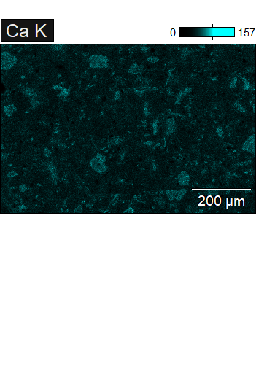

Data Type: Counts
Image Resolution: 512 by 340
Image Pixel Size: 1.68 µm
Map Resolution: 512 by 340
Map Pixel Size: 1.68 µm
Acc. Voltage: 20.0 kV
Magnification: 250
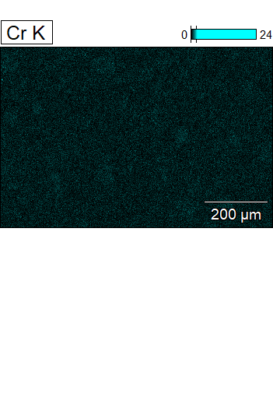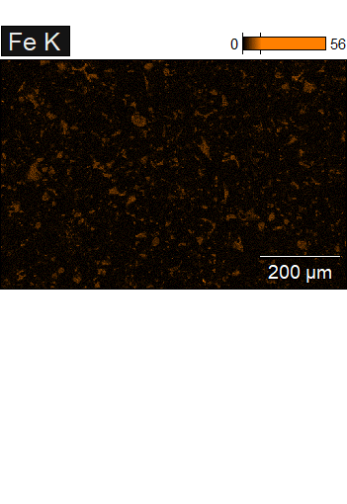

Data Type: Counts
Image Resolution: 512 by 340
Image Pixel Size: 1.68 µm
Map Resolution: 512 by 340
Map Pixel Size: 1.68 µm
Acc. Voltage: 20.0 kV
Magnification: 250
