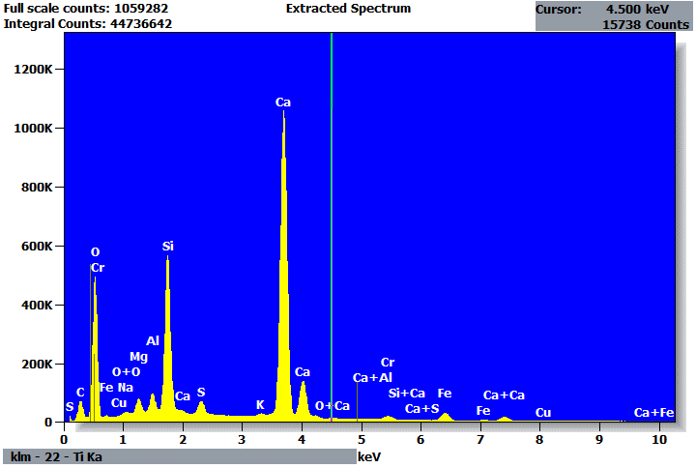

Quantitative Results for: Extracted Spectrum
Element | Net  Counts | Int.  Cps/nA | Weight % | Atom %
C | 692070 | --- | 4.51 | 8.00
O | 3930837 | --- | 48.07 | 64.01
Na | 117454 | --- | 0.41 | 0.38
Mg | 534968 | --- | 1.24 | 1.08
Al | 669730 | --- | 1.19 | 0.94
Si | 6001094 | --- | 9.54 | 7.23
S | 759320 | --- | 1.09 | 0.72
K | 79986 | --- | 0.14 | 0.08
Ca | 15228839 | --- | 30.92 | 16.43
Cr | 170877 | --- | 0.66 | 0.27
Fe | 428392 | --- | 2.14 | 0.82
Cu | 11794 | --- | 0.10 | 0.03
Total |  |  | 100.00 | 100.00

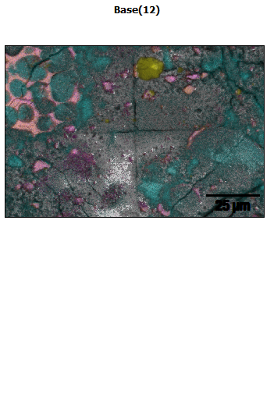
Data Type: Counts
Image Resolution: 512 by 340
Image Pixel Size: 0.24 µm
Map Resolution: 512 by 340
Map Pixel Size: 0.24 µm
Acc. Voltage: 20.0 kV
Magnification: 1750
