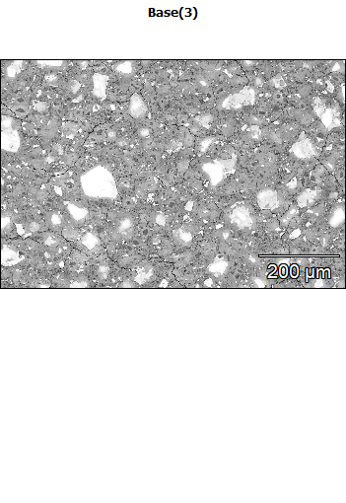
Data Type: Counts
Image Resolution: 1024 by 682
Image Pixel Size: 0.84 µm
Map Resolution: 512 by 340
Map Pixel Size: 1.68 µm
Acc. Voltage: 7.0 kV
Magnification: 250
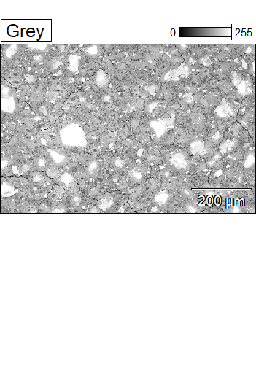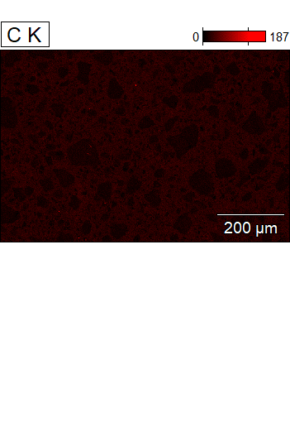

Data Type: Counts
Image Resolution: 1024 by 682
Image Pixel Size: 0.84 µm
Map Resolution: 512 by 340
Map Pixel Size: 1.68 µm
Acc. Voltage: 7.0 kV
Magnification: 250
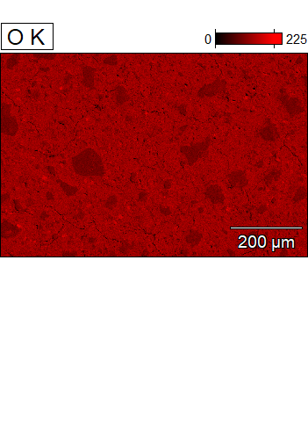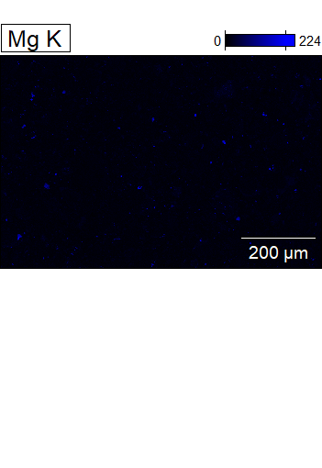

Data Type: Counts
Image Resolution: 1024 by 682
Image Pixel Size: 0.84 µm
Map Resolution: 512 by 340
Map Pixel Size: 1.68 µm
Acc. Voltage: 7.0 kV
Magnification: 250
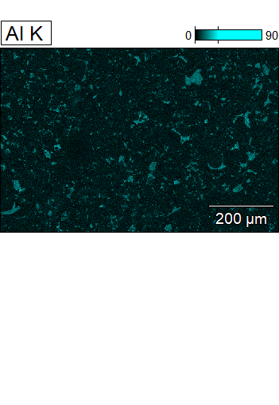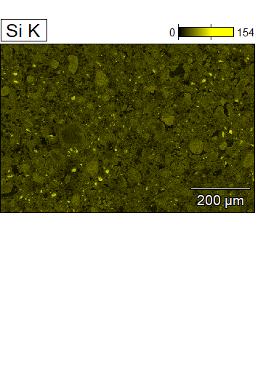

Data Type: Counts
Image Resolution: 1024 by 682
Image Pixel Size: 0.84 µm
Map Resolution: 512 by 340
Map Pixel Size: 1.68 µm
Acc. Voltage: 7.0 kV
Magnification: 250
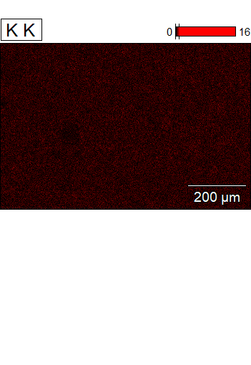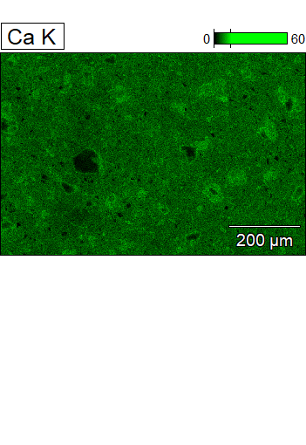

Data Type: Counts
Image Resolution: 1024 by 682
Image Pixel Size: 0.84 µm
Map Resolution: 512 by 340
Map Pixel Size: 1.68 µm
Acc. Voltage: 7.0 kV
Magnification: 250
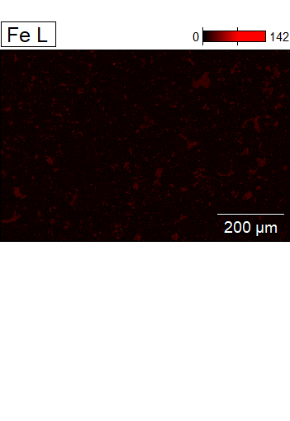
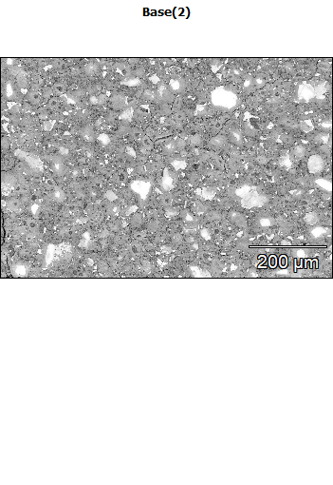
Data Type: Counts
Image Resolution: 1024 by 682
Image Pixel Size: 0.84 µm
Map Resolution: 512 by 340
Map Pixel Size: 1.68 µm
Acc. Voltage: 7.0 kV
Magnification: 250
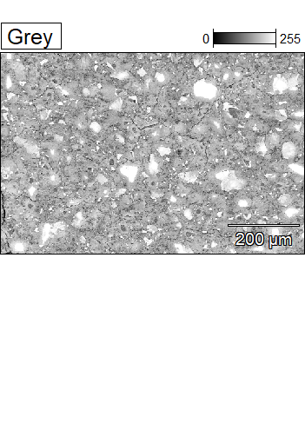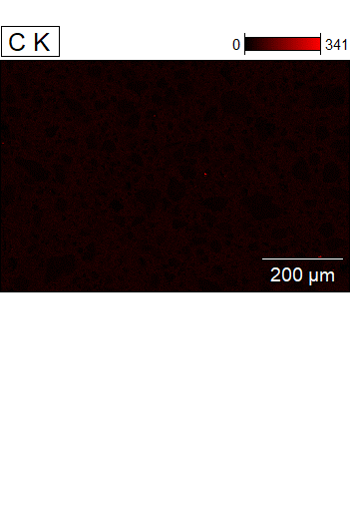

Data Type: Counts
Image Resolution: 1024 by 682
Image Pixel Size: 0.84 µm
Map Resolution: 512 by 340
Map Pixel Size: 1.68 µm
Acc. Voltage: 7.0 kV
Magnification: 250
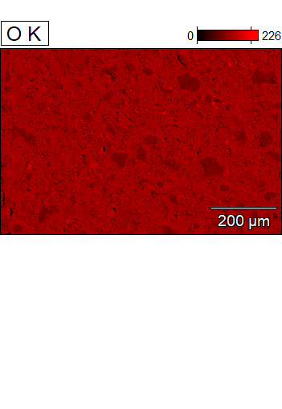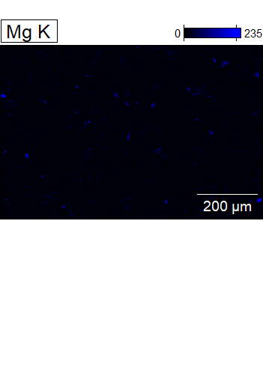

Data Type: Counts
Image Resolution: 1024 by 682
Image Pixel Size: 0.84 µm
Map Resolution: 512 by 340
Map Pixel Size: 1.68 µm
Acc. Voltage: 7.0 kV
Magnification: 250
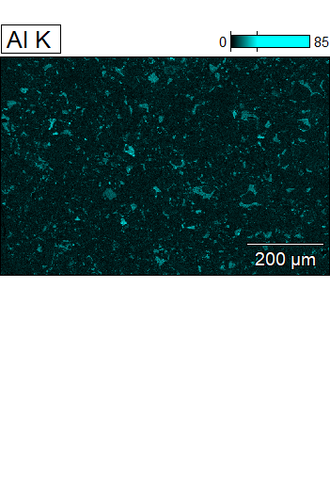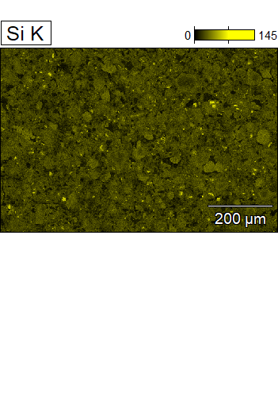

Data Type: Counts
Image Resolution: 1024 by 682
Image Pixel Size: 0.84 µm
Map Resolution: 512 by 340
Map Pixel Size: 1.68 µm
Acc. Voltage: 7.0 kV
Magnification: 250
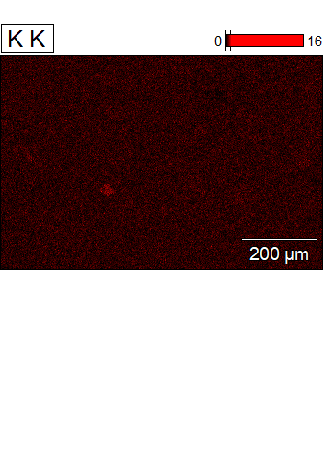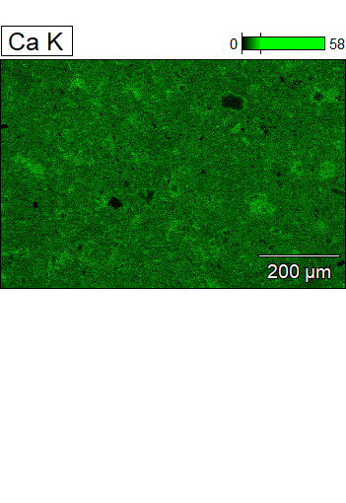

Data Type: Counts
Image Resolution: 1024 by 682
Image Pixel Size: 0.84 µm
Map Resolution: 512 by 340
Map Pixel Size: 1.68 µm
Acc. Voltage: 7.0 kV
Magnification: 250
